**Spring**

* **Intro:**

Spring is a Java Framework that makes it easier, quicker and safer to code 🡪 <https://spring.io/>

Spring framework evolves fast, providing modern tools for coding. Spring framework provides tools such as Spring Boot, designed to build any simple Java App; Spring Cloud, designed for distributed services based on microservices architecture; and Spring Cloud Data Flow, designed to connect Enterprises to IoT.

To this day, Spring Framework version is at 5.0 and Spring Boot is at 2.0. We have a technologies stack called Reactor, which provides two different architectural approaches: Reactive Stack and Servlet Stack.

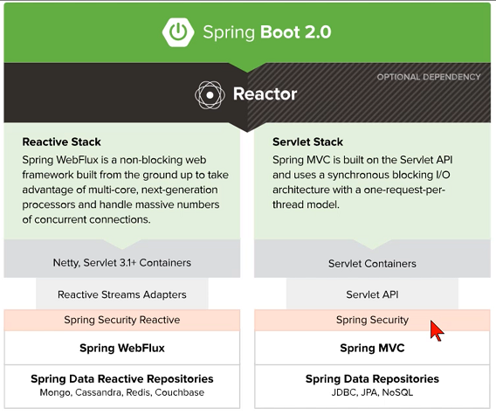

Basically, any Java application can now be easily build using Spring Boot, which we will be using, avoiding xml configurations and others.

Spring Initializr is the base to get started into building anything such as REST APIs, WebSockets, web streaming, tasks, etc. Security is simplified as well as SQL and NoSQL support. Even app servers are embedded into Spring Boot. Works with any IDE through dependencies.

* **Tools:**

We will be using Java version 15 JDK, the latest stable version: <https://www.globalmentoring.com.mx/software/jdk15/index.html>

<https://www.oracle.com/java/technologies/javase/jdk15-archive-downloads.html>

And Netbeans as the preferred IDE.

* **JDK Installation:**

[**https://www.oracle.com/java/technologies/javase/jdk15-archive-downloads.html**](https://www.oracle.com/java/technologies/javase/jdk15-archive-downloads.html)



This is the default installation route:



* **Apache Netbeans Installation:**

[**https://netbeans.apache.org/download/index.html**](https://netbeans.apache.org/download/index.html)



Make sure that the Netbeans version supports the JDK version you intend to use. During Netbeans installation, provide the local route where your jdk version is stored. Unplug antivirus if it interferes with the IDE installation.

* **Apache Netbeans IDE:**

Change to dark theme: <https://www.geeksforgeeks.org/how-to-change-the-theme-of-netbeans-12-0-to-dark-mode/>

Tools 🡪 Options 🡪 Appearance 🡪 Look and Feel Tab 🡪 Dark Nimbus 🡪 Apply 🡪 Restart Netbeans.

* **Spring Initializr:**

To start a Spring Project using Initializr, go to: <https://start.spring.io/>

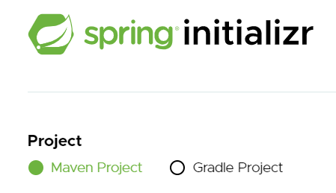

First choose the preferred Java Dependency Manager.

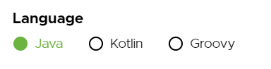

Then select the language to be used in your code.

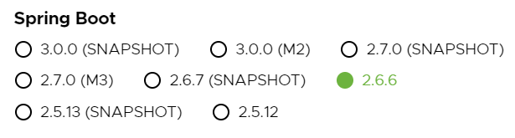

Then select the Spring Boot version to be used, SB will facilitate tasks such as the dependency management or the app server to be used. Use the stable version preferably, not SNAPSHOT or M.

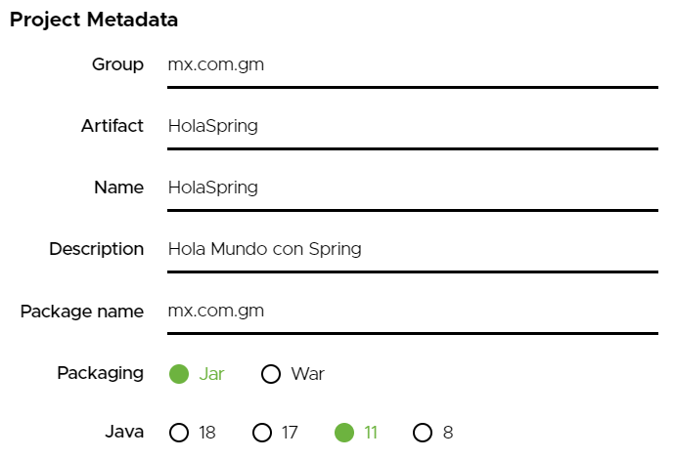

Provide the project metadata in order to create the working tree. Select the packaging type and remember that Jars can also now be used for web apps. Select the Java version to be used, in this case since 15 is not an option, select the immediate previous version.

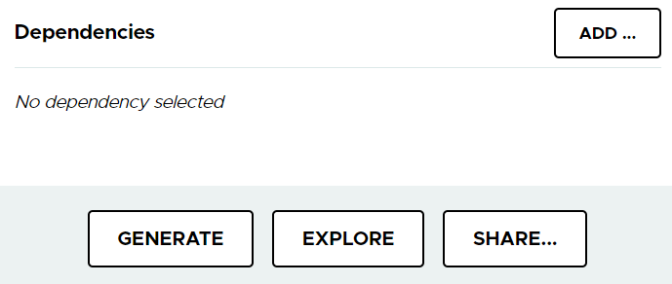

Last, we have the option to add dependencies. Remember Spring Boot already adds some, unlike simple Spring projects.

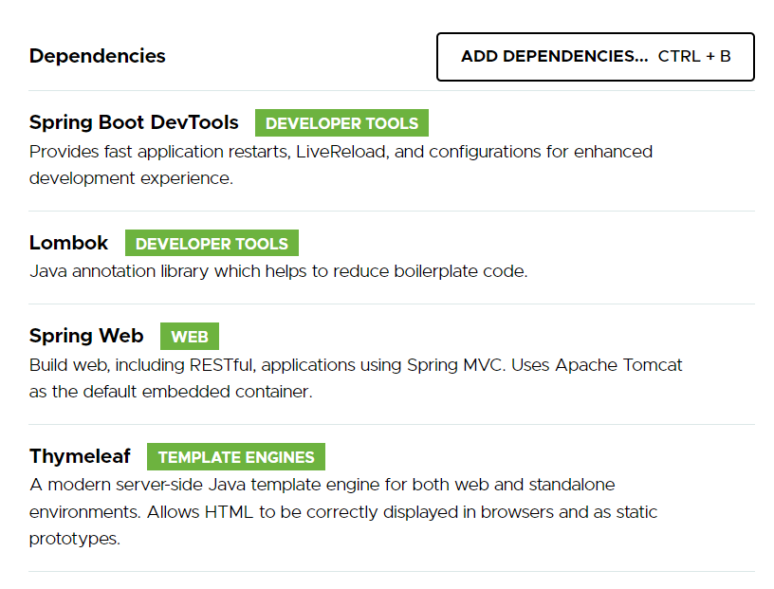

Add the dependencies relevant to your project and hit Generate.

Basically, Spring will act as our Container, while Spring Boot will facilitate all of the tedious configurations for us.

A zip file will be provided with our project. Unzip it and save it somewhere. It contains all of the files to your ready to run project. It even has a file for a Maven simulator (mvnw.cmd) in case you don’t have it installed.

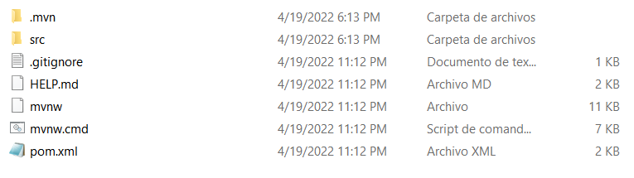

In src 🡪 main 🡪 java our class files will be contained. While in src 🡪 main 🡪 resources our configuration static files will be stored (js, css, images, etc), our Thymeleaf templates, and the application.properties file where we will be able to define the spring framework configurations (login, datasource connections, ports, etc).

To import this project into Netbeans, go to File 🡪 Open Project 🡪 Select Project Folder.

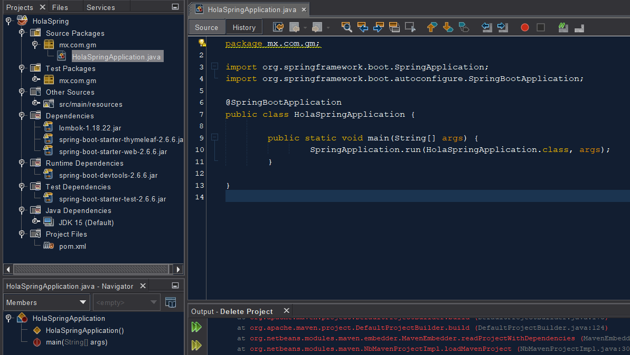

* **Create Project from Scratch with Spring Boot Plugin in Netbeans:**

Download the Spring Boot Netbeans Plugin 🡪 <https://plugins.netbeans.apache.org/catalogue/?id=4>

Go to Netbeans Tools 🡪 Plugins 🡪 Downloaded Tab 🡪 Add plugins 🡪 select plugin storage location 🡪 Open 🡪 Install 🡪 Accept terms 🡪 Install 🡪 Continue 🡪 Restart IDE.

Now we can create our project from scratch. Go to File 🡪 New Project 🡪 Java with Maven 🡪 Spring Boot Initializr Project 🡪 Next 🡪 Introduce data, select desired dependencies, name and location 🡪 Select path the closest to C:// to store project 🡪 Finish.

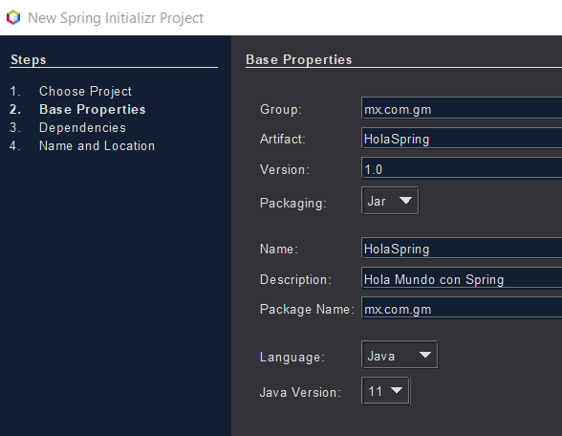

Run the project for the first time to make sure that the dependencies are downloaded, go to project and right click Clean and Build. This will download any missing dependency. Make sure the output throws BUILD SUCCESS, otherwise disable security software such as antivirus that might interfere with dependency download.

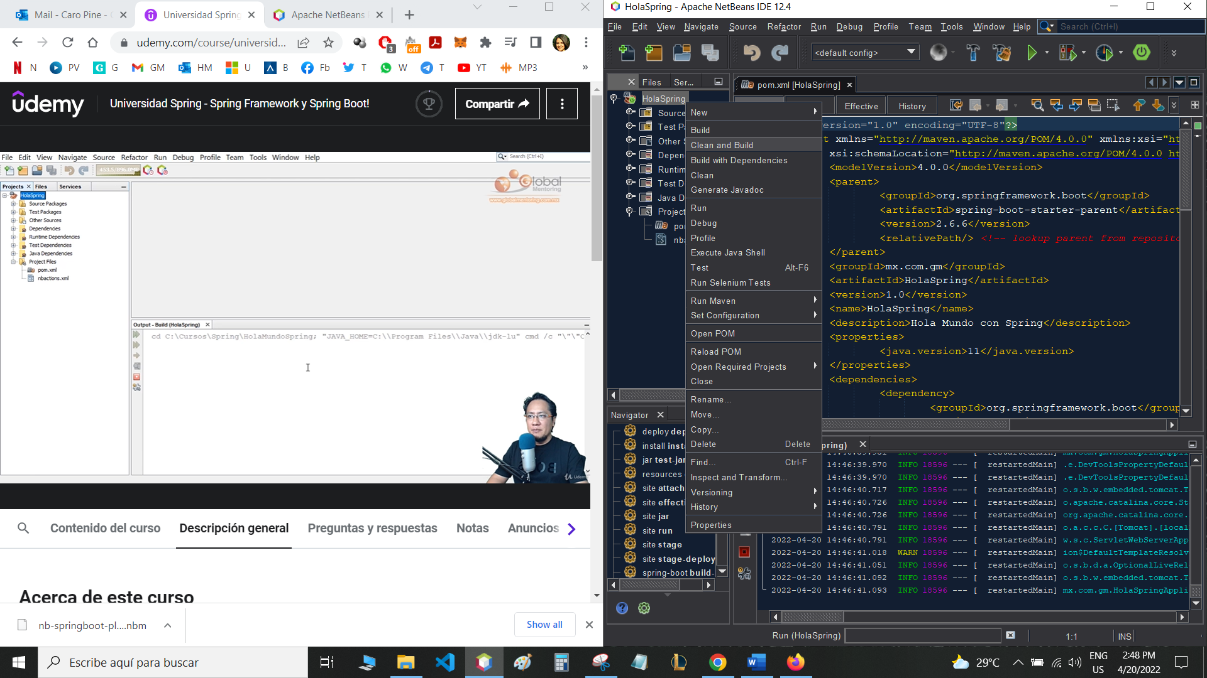

If your dependencies are still not being downloaded, close your IDE, then go to C://Users/myuser/.m2 (this folder contains all maven dependencies) 🡪 Erase the repository folder containing all dependencies.

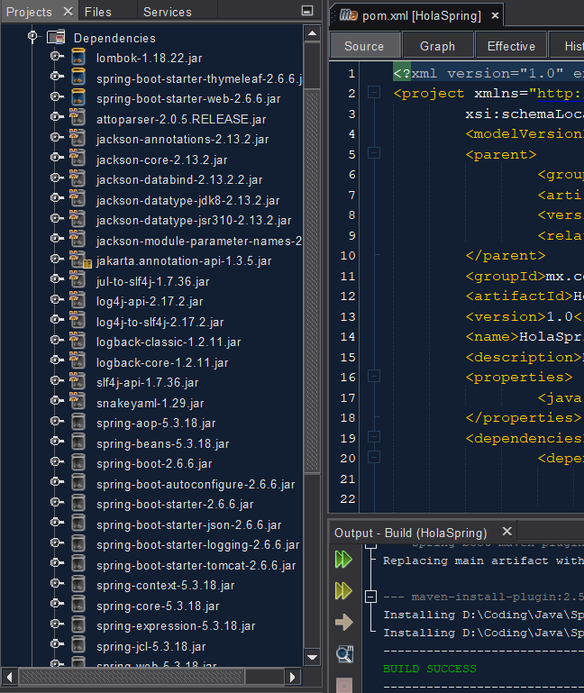

You can now appreciate all of the dependencies downloaded. If you don’t get BUILD SUCCESS, one of them might be corrupt and you can try deleting the folder again as stated above.

* **pom.xml:**

Now let’s take a look at our main project configuration file 🡪 pom.xml

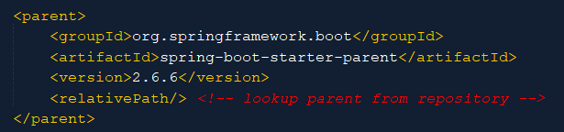

The parent dependency will be spring-boot-starter-parent, in this case version 2.6.6.

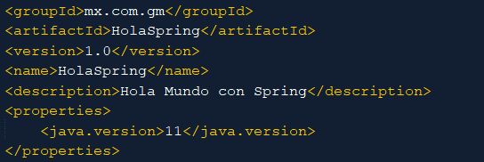

Project info will also be stated here, as well as the java version.

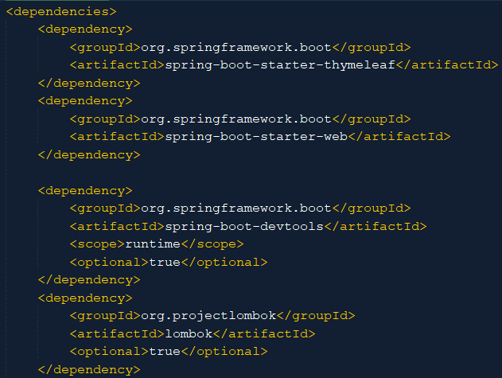

These are secondary dependencies, the ones we decided to import and they will indirectly import many other dependencies to their name.

* **Main App Class:**

Our main app class is a regular java class which was automatically created by Spring Initializr, but with the @SpringBootApplication annotation.

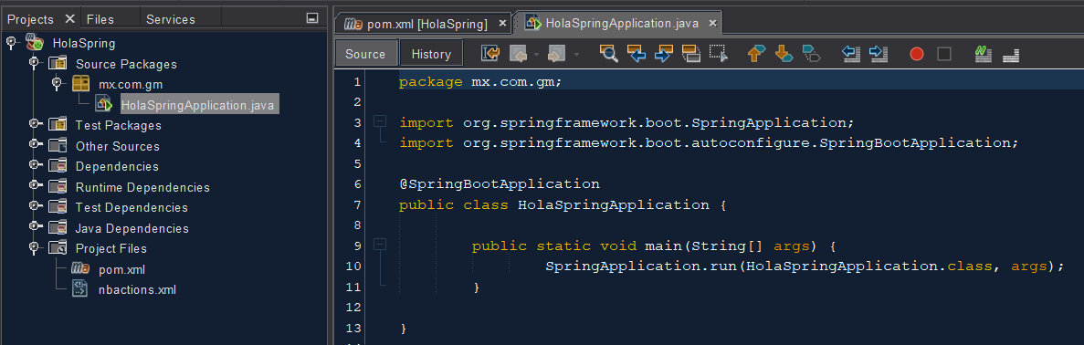

The application class must have a main method, inside which we will be able to run the Spring Application. Right click, run file to execute the java app.

The @SpringBootApplication class is composed by several other annotations itself, this is the way SpringBoot facilitates Java App building.

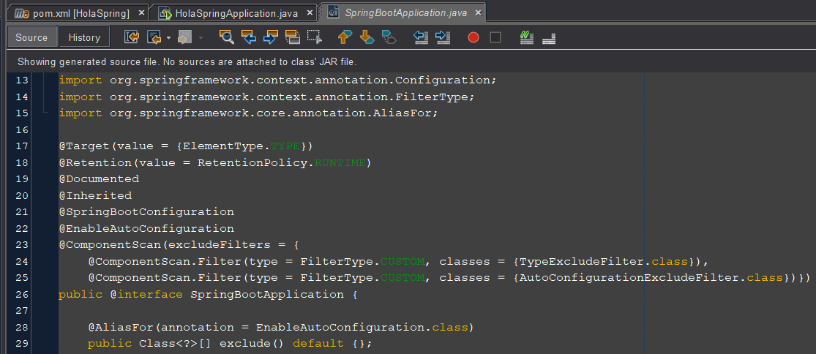

Since Spring Framework is a java classes (beans) container, these beans will live inside the Spring container.

* **Executing App:**

Right click over main app class (annotated with @SpringBootApplication) and hit Run File.

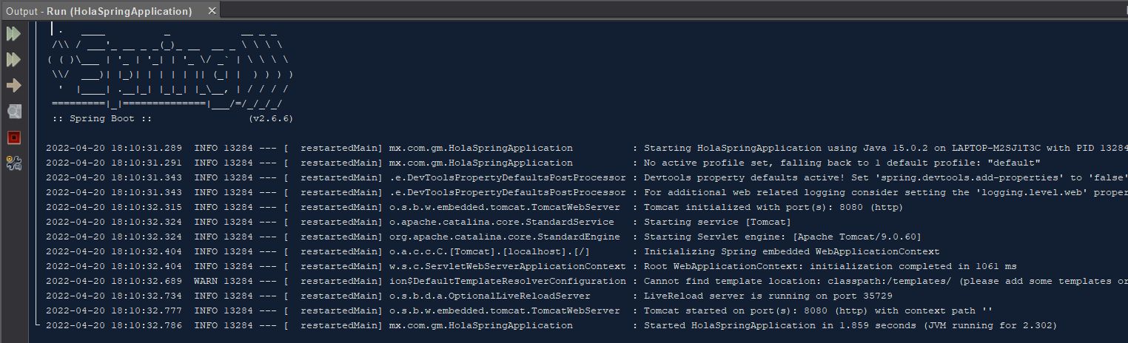

Watch the output log. This will tell you whether the application is running and in which Tomcat port.

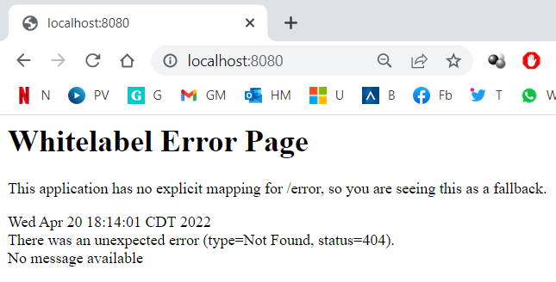

You can now deploy your app in any browser.

* **REST Controller:**

Since Spring a Java Classes Container, all of our java classes need to be inside the same package containing the @SpringBootApplication annotated class, in this case the package is called mx.com.gm.

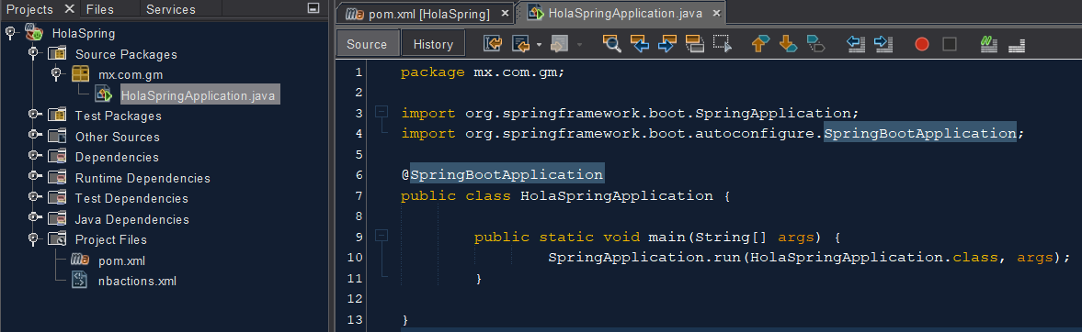

The @ComponentScan annotation inside the SpringBootApplication class, will make sure that all classes inside this package are scanned.

So, let’s create a new class inside this package for our REST Controller. A REST Controller will allow us to send information to our browser.

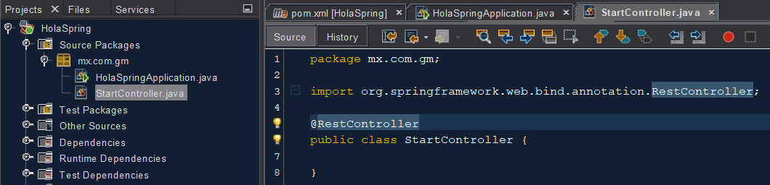

Our new class is called StartController.java and it needs to be annotated as a @RestController so that Spring can acknowledge it. Make sure to import the right class (org.springframework.web.bind.annotation.RestController;).

Since @RestController has inherited the @Component annotation, this class will be added to the Spring Container and managed by it.

Let’s define a method for our controller class:

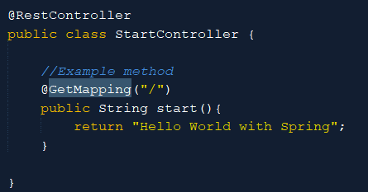

This method will need a unique path (in the URL) in order to be executed, this is known as “Mapping”. Se we will use the @GetMapping() annotation in order to define this path. Implicit in the annotation comes the request type, which is a GET. Since we defined the path to be “/”, this is how we can access this method from our browser:



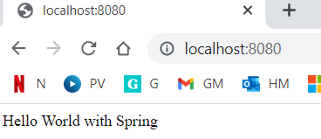

Thanks to the devtools dependency we added to our project, whenever we save changes into our project, the tomcat server automatically reflects them into our app, a refresh page will do.

Now let’s add some log information into our Controller class, use the @Slf4j annotation belonging to Lombok. Use log.LEVEL To register log info.

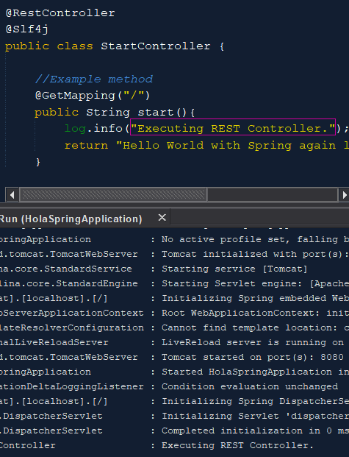

* **Resources Folder:**

There’s another important folder called Other Sources. This folder contains the src/main/resources folder, which contains a default package with the application.properties file. This is the Spring configuration file. It’s empty by default since all default configs have already been applied. The other packages will contain static files and html templates.

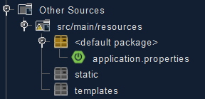

Let’s modify some default values in the application.properties file on purpose.

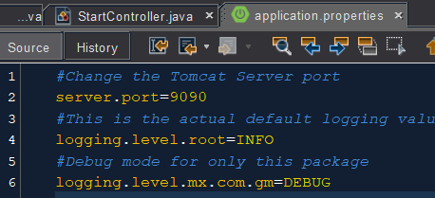

Now stop and restart the server, since we changed ports.

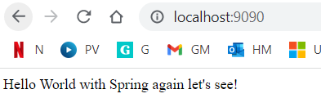

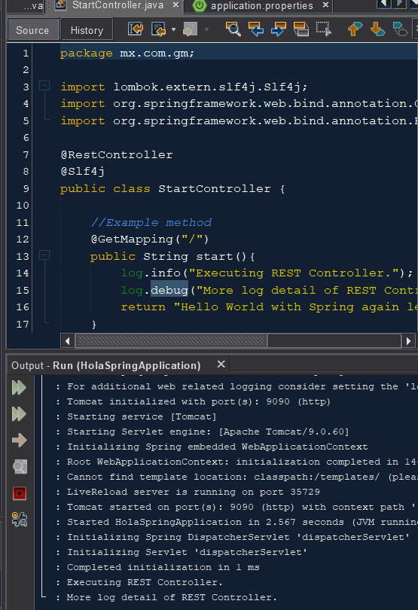

We can now see the new information deployed.

* **Project with Thymeleaf and Spring MVC:**

Copy the previous project and rename it.

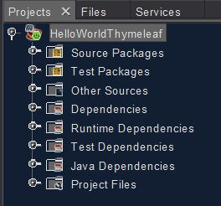

The first change in our project will be to use a simple controller in order to align with Spring MVC and the deployment technology to be used will be Thymeleaf, which uses html views by default.

Use @Controller annotation, which works similarly to @RestController. The main difference is the return type. @Controllers return the name of the view to be deployed.

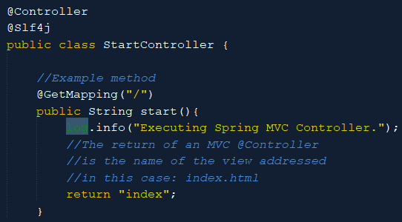

Create said view in the respective templates package (for Thymeleaf):

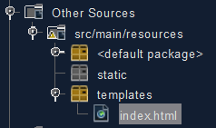

Now browse for the method mapping to get index.html shown:

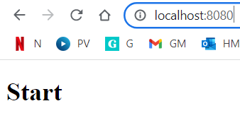

* **Dynamic Info with Thymeleaf:**

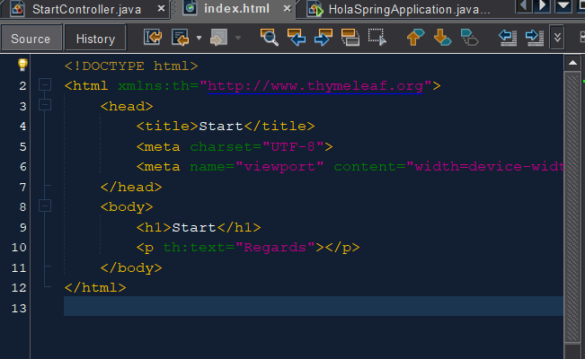

In order to be able to manage dynamic information in our view, we will need to declare the thymeleaf namespace. Disable HTML error check.

Add a paragraph thymeleaf text to send a message.

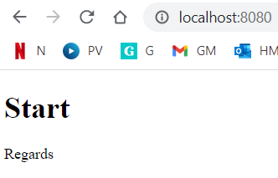

Remember Thymeleaf will automatically store cache for your app. To avoid this, declare it in the application properties.

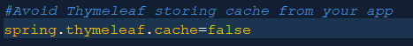

It’s also useful to have Livereaload Chrome extension so that we can automatically refresh anytime we add changes in our code.**Sharing Info to View with Spring MVC and Thymeleaf:**

In order to send info to our view, we will need to send the Model parameter into our method.

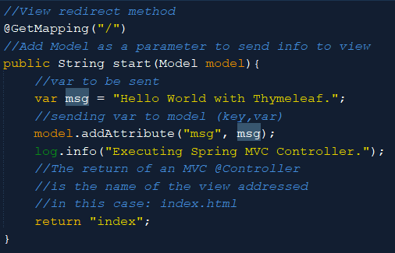

Since Spring introduces dependency injection concept, the moment we declare our class as a @Controller this will be available in the Spring Factory.

When we use @GetMapping() type methods, we can receive the Model argument for this method and use model’s methods. This way, Spring factory will instantiate automatically any of the classes we decide to use as Parameters.

Now, we have defined a model attribute and the key we set for it will now be useful to reference it from the view through expression language 🡪 ${*key*}.

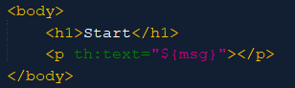

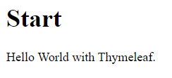

We can also use a properties file to set a message:

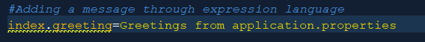

And call it from the Controller, for which we will need to define a variable annotated with the @Value(${*key*}) annotation, make sure to import this class from springfactory.

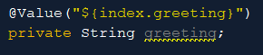

Through dependency injection, spring factory will assign the value to this newly declared variable.

Now simply add it to the model:

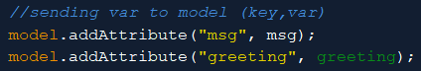

So that we can retrieve it at the view:

* **Domain Class:**

Now we will create a domain class: Person.java, which remember needs to be inside our main package for Spring to scan it and acknowledge it:

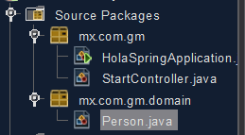

Use Lombok annotation @Data in order to automatically create the boilerplate standard code for Java Beans for our domain class (empty constructor(), getters, setters, toString(), equals() and hashCode() methods).

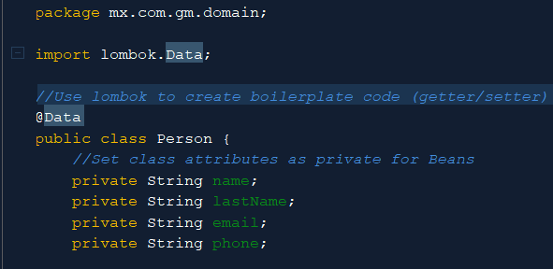

Add the object to the controller so that we can call it from the view:

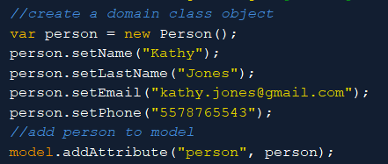

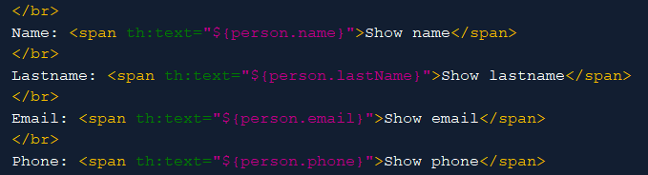

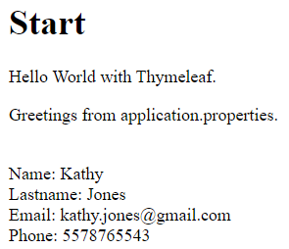

* **Iterating Objects with Thymeleaf:**

We will be creating a list of People (Domain Class Objects) for its iteration.

Watch these two ways to create and fill the array list:

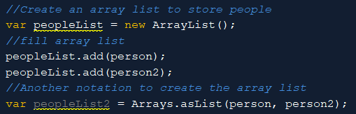

Now let’s add it to the model:

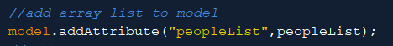

And use it to display info in the view:

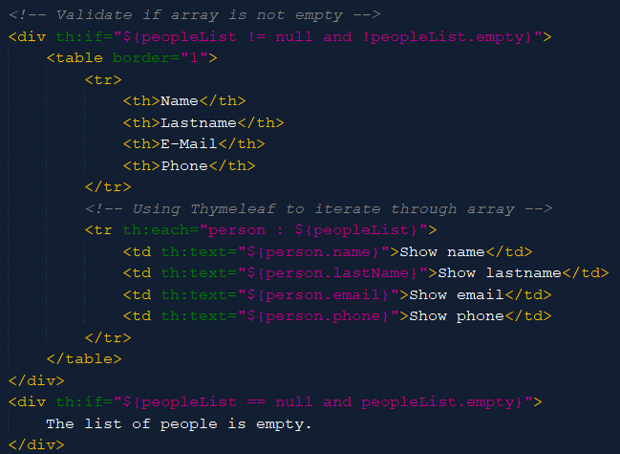

We used a table to display the information in the view side. Thymeleaf can iterate through arrays by using the “*each”* label. Assign a variable name to the name of the array you sent to the model.

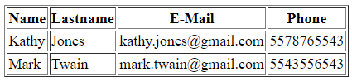

* **MySQL:**

Download MySQL Community Server: <https://dev.mysql.com/downloads/mysql/>

Customize your installation to include the relevant software only The Database Manager (MySQL Server) and its IDE (MySQL Workbench). Select Custom Installation:

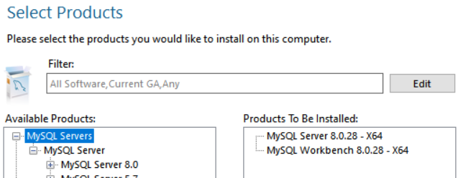

When configuring the DB Server, take note of relevant data such as the port assigned and password:

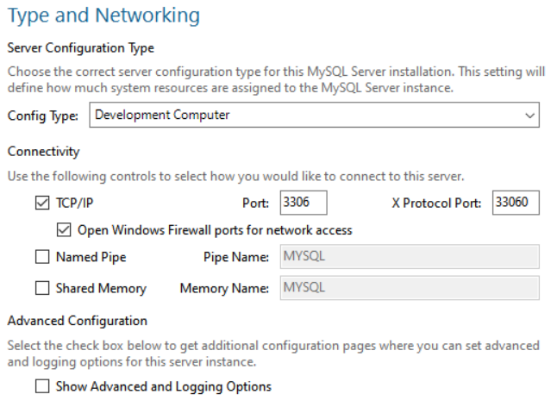

Root password: admin

This option will allow for the DB to be automatically started when we start Windows.

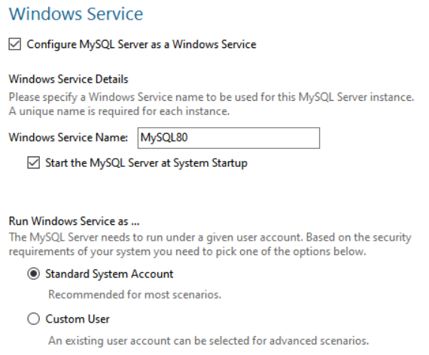

If you had trouble in any of these steps, please disable antivirus software that might be interfering with the setup.

Now in the MySQL IDE, go to Database 🡪 Connect to DB 🡪 Select Local instance 🡪 Input known data 🡪 Store in vault and input root user password 🡪 OK.

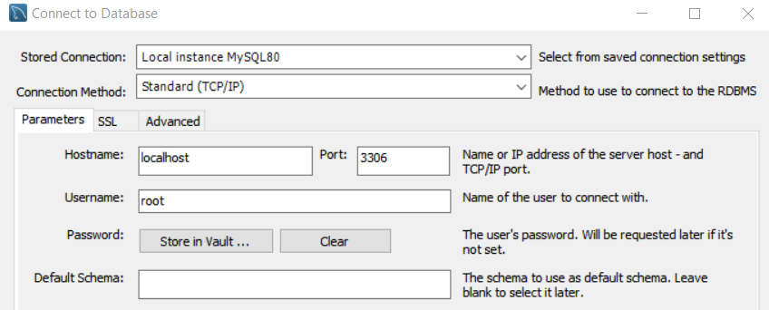

The selected Schema will be the one by default. A Schema is basically a DB in MySQL.

* **MySQL – Creating DB:**

Go to the Create a new Schema icon and click it:

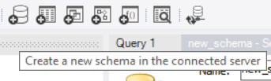

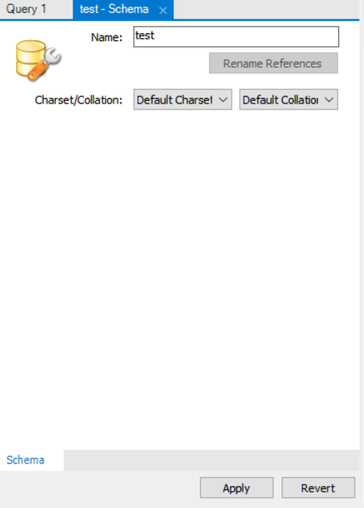



Give the DB a name and Apply 🡪 Apply 🡪 Finish.

Now from the Schemas Tab, create a new table:

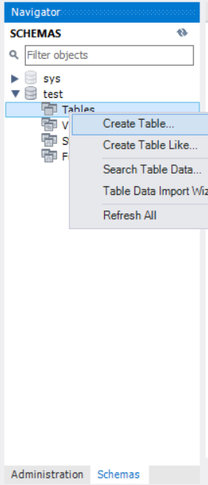

Now let’s populate the DB with a table with the data that the Person class holds:

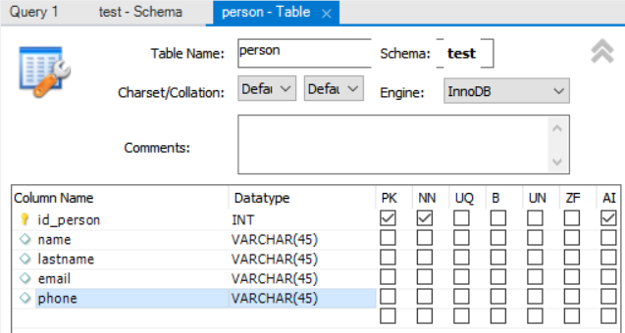

The first column will be the Primary Key, it has to be Not Null and since the Id needs to be different for each row, set it as Auto-Incrementable.

Hit Apply and the IDE will automatically generate the SQL code to be applied as a script to the DB. Hit Finish.

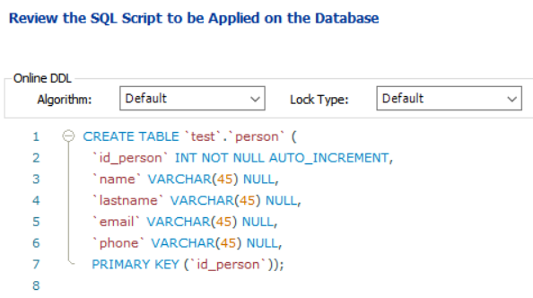

We can now see the table created. Hit Select Rows in order to populate the table:

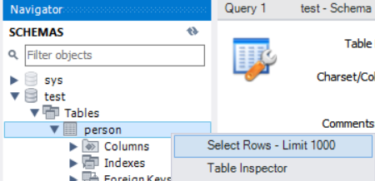

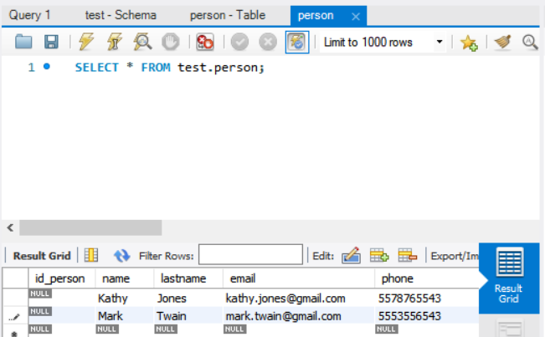

Add some example info and hit Apply.

SQL:

INSERT INTO `test`.`person` (`name`, `lastname`, `email`, `phone`) VALUES ('Kathy', 'Jones', 'kathy.jones@gmail.com', '5578765543');

INSERT INTO `test`.`person` (`name`, `lastname`, `email`, `phone`) VALUES ('Mark', 'Twain', 'mark.twain@gmail.com', '5545553556543');

Close the person table tab and open it again to watch the table updated, notice an ID has been assigned to each row:

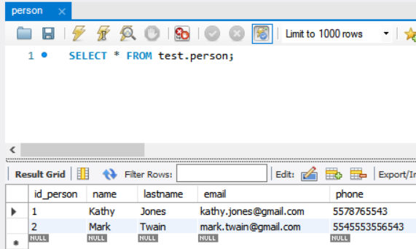

* **MySQL – Connect from Netbeans:**

From Netbeans go to Window 🡪 Services 🡪 Databases 🡪 Right click 🡪 New Connection:

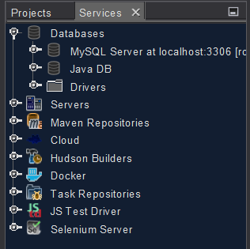

Select MySQL Driver, if it’s missing, download it from the URL provided by the IDE:

<https://dev.mysql.com/downloads/connector/j/> 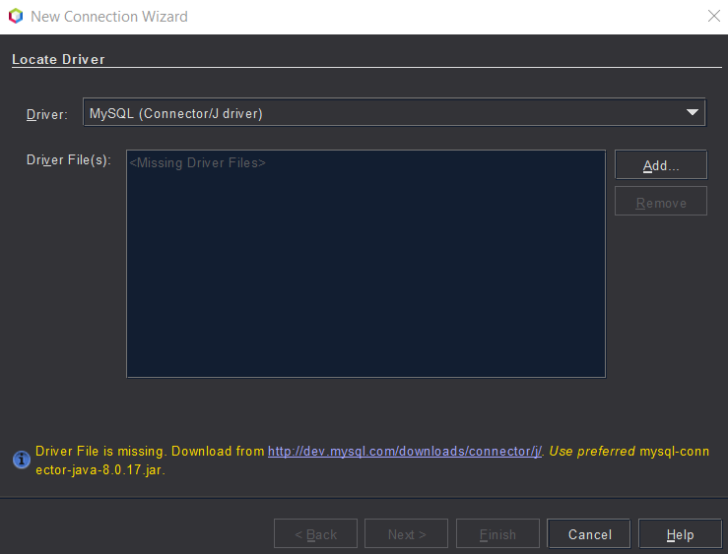

Select the Platform Independent OS:

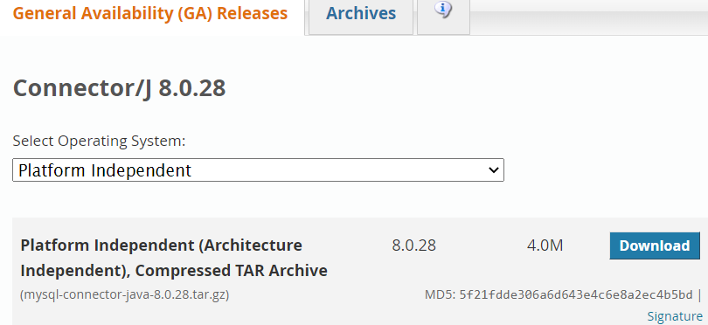

Retrieve the jar file from the zip file and store it in your local:



Now Add the driver into the Netbeans Connection Wizard:

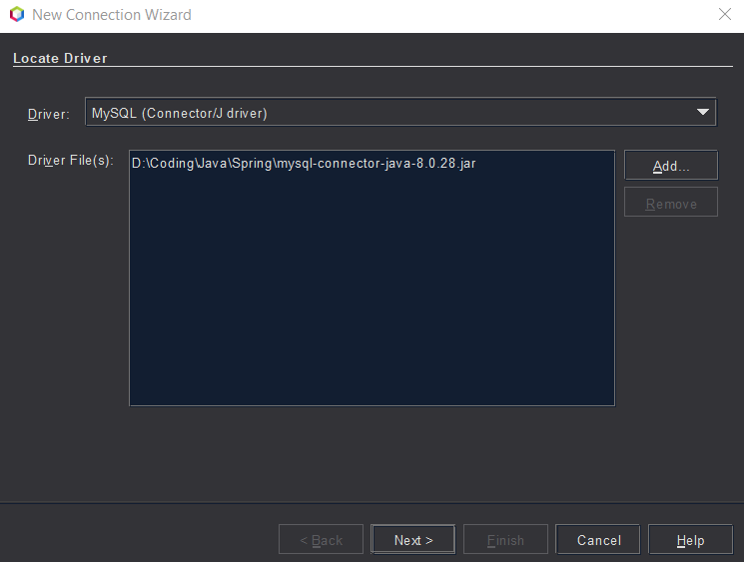

Hit Next and enter your DB information:

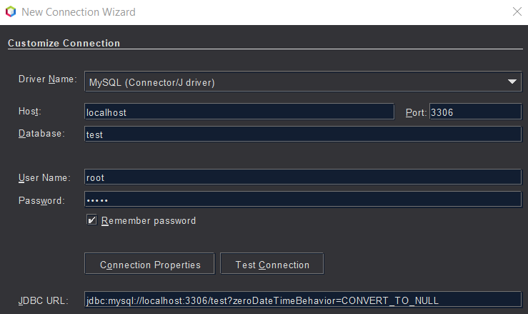

We will modify the JDBC URL a little bit by adding some parameters with &: jdbc:mysql://localhost:3306/test?zeroDateTimeBehavior=CONVERT_TO_NULL&useSSL=false&useTimezone=true&serverTimezone=UTC



Hit Test Connection to make sure everything is ok:

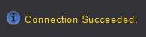

Hit Next, and set the connection name right:



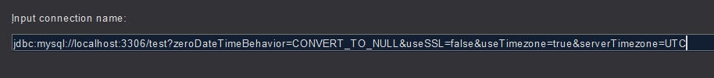

Now hit Finish.

We can now see our DB info from Netbeans:

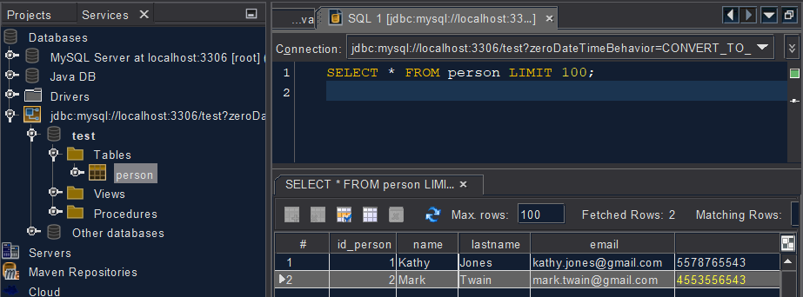

Right click on person table 🡪 View Data.

* **Spring Data:**

In order to work with our DB dynamically, the first thing we need to do is to add the missing dependencies (Spring Data and MySQL Driver) into our pom file:

The Spring Wizard can help us with this taks. Go to the dependencies tag in your pom file:

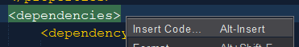 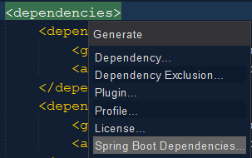

Right click 🡪 Insert Code… 🡪 Spring Boot Dependencies…

Select Spring Data JPA and MySQL Driver and hit OK:

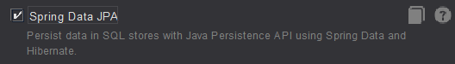

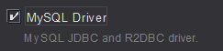

Both dependencies have been added to our pom file. The java connector version will automatically be managed by Spring. Remember to right click on your project and hit Clean and Build in order for the new dependencies to be downloaded.

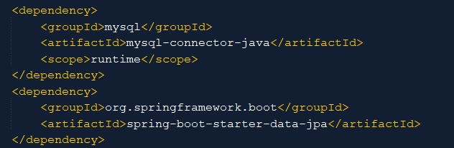

* **Spring Data – Configure Connection to DB:**

Go to the application.properties file in your Spring project and let’s feed it all of the DB information:

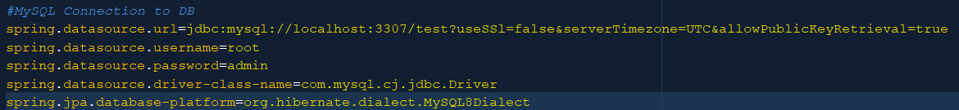

*Note: If your port is 3306 (default) you don’t need to write it, otherwise you do.*

The JDBC URL built for MySQL8 requires certain parameters that are concatenated with &.

Remember the Spring default for JPA is Hibernate, so if we want our queries in execution to be shown, we need to define a hibernate property:

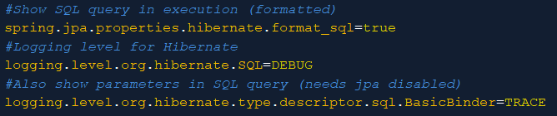

The first property shows the query in an SQL format. The second property allows us to actually visualize the query. The third property is in TRACE mode, the most basic mode, and it will allow us to see the query parameters (as long as the first property is disabled).

Clean and Build project to check for errors.



We can appreciate that JPA EntityManagerFactory was automatically initiated, and a persistence unit “default” was also automatically created, so a persistence.xml file will not be necessary.

Now let’s turn our domain class into an Entity, use javax.persistence libraries, not hibernate. Everything will be managed via JPA, hibernate itself will only be implemented through JPA.

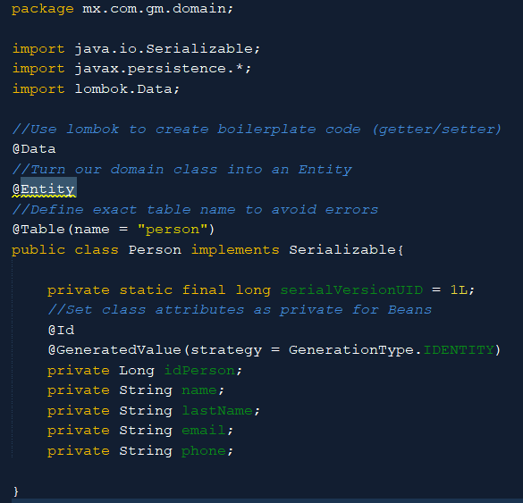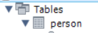

Our domain class will now be annotated with @Entity, to be defined as a persistence domain object, which basically represents a table in a DB. Each entity instance will represent a row in it. The @Table annotation is good to clarify the real Table name, since it’s not the exact same name as the one defined in the Schema, it could lead to errors.

Implement Serializable interface for data transfer and storage and define the UID for it.

Finally, we need to provide que class or table id, use the @Id annotation above the variable that will be used as the table Primary Key, in this case: idPerson, and provide a method for its generation via the @GeneratedValue() annotation.

* **Spring Data – DAO Classes:**

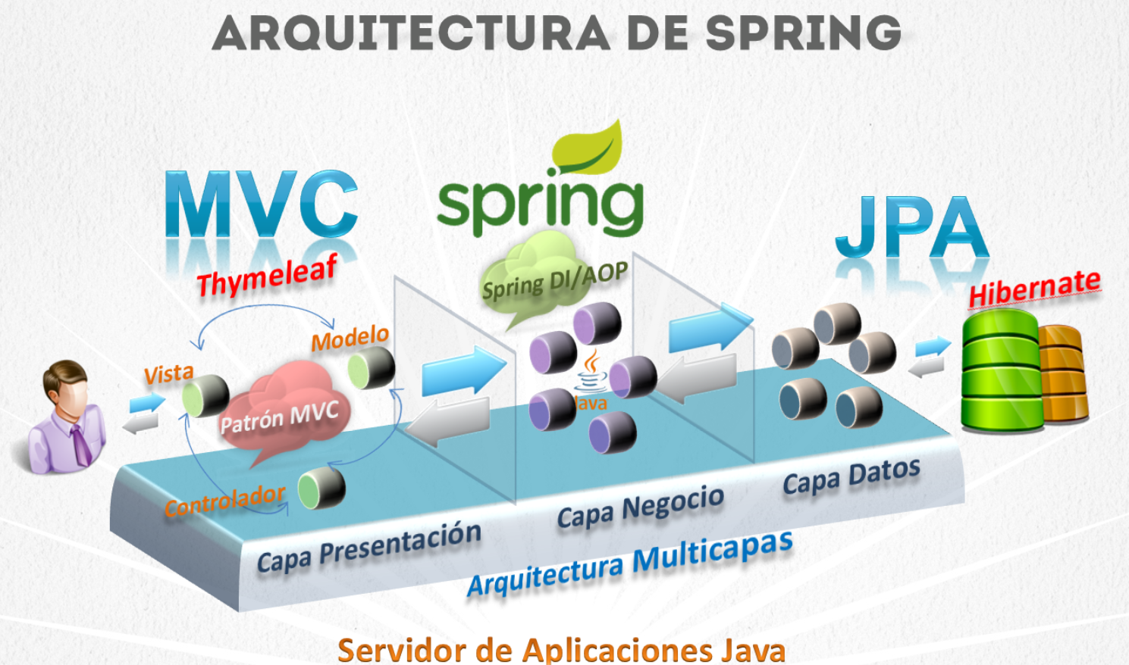

There are several ways to define Spring Architecture.

Let’s say we have a Multilayer architecture (logical layers) which lives inside an App Server (Tomcat).

First of all, we have our Presentation Layer. We have chosen MVC model and implemented it through Spring. We use Thymeleaf as the display technology. Our View is presented via HTML. Our model is the Person class. Our Controller has also been created to reference our view.

Second, comes the Business Layer. We will interact with the transactional concept here later.

Third and last, comes the Data Layer. We are using JPA to implement hibernate in order to connect to our MySQL Database. We have created Entity classes or tables to withhold our data.

In order to retrieve info directly from the Presentation layer View, we will need Spring Repositories or DAO (Data Access Object) classes.

In the past, it was necessary to create an interface with the CRUD methods and then create a class with the @Repository annotation to have it implement this interface.

Nowadays, we create an interface which extends from CrudRepository<*Entity Type to manage*, *Primary Key Type*>.

This way, Spring boot will create a default implementation, which means we no longer have to create a class to implement this interface. Remember it’s best practice to start interface names with “i”.

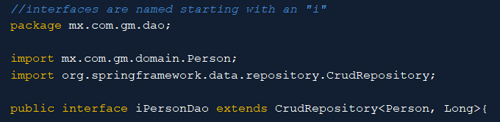

On the inside, CrudRepository interface contains all the classic methods for Entities:

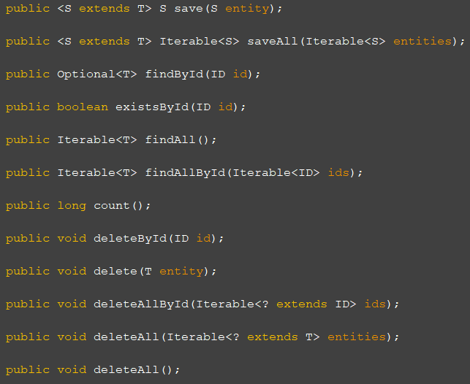

Now inject this interface into the Controller by using the @Autowired annotation:

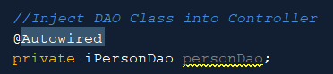

Now let’s make use of our iPersonDao available methods:

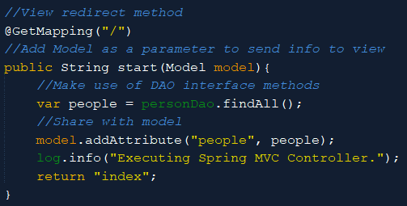

And finally let’s take these changes to our View:

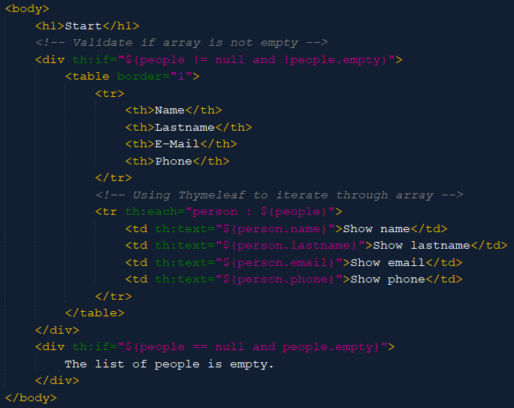

Remember every single column on the Schema (except for PK) should match the domain class attributes with the exact same name:

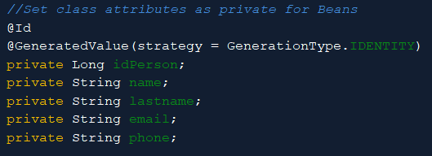 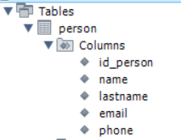

Now run the application to view the results in your browser:

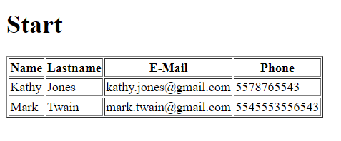

So far, our project is organized into different container packages, like this:

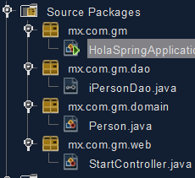

* **Spring – Service/Business Layer:**

For the Service Layer, we need to follow the client’s requirements or Business Rules. We will create a new package in our project for our services:

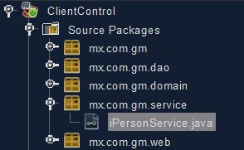

Service classes are not actually classes but interfaces, this interface will contain the contract and the methods to be implemented.

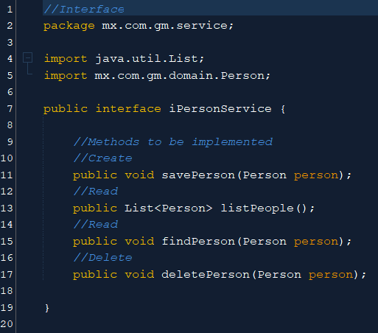

Now we will need a class to implement this new interface.

The class that implements the interface will be called the same but with the Impl keyword attached at the end. This class needs to be annotated with @Service so that it can later be injected as the service implementation inside our controller.

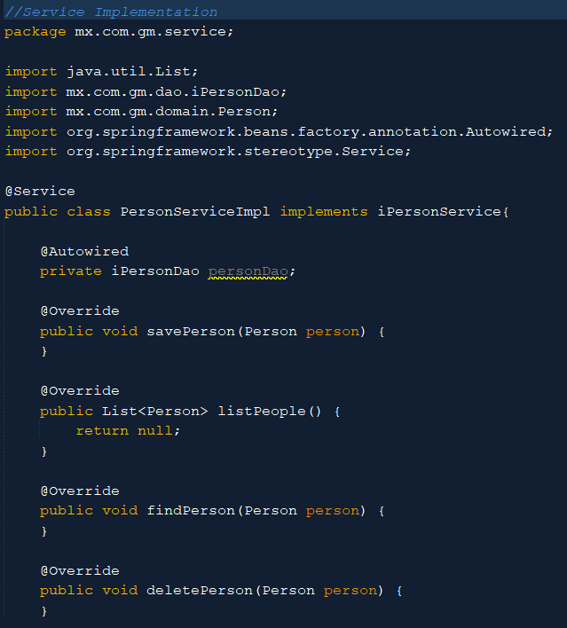

We will inject our Dao class inside this service implementation (@Autowired). This way, our controller won’t have to interact directly with the Data Layer, but instead it will interact with the Business Layer. This same class will connect Business Layer to Data Layer.

Our interface methods have all been defined in our Implementation class.

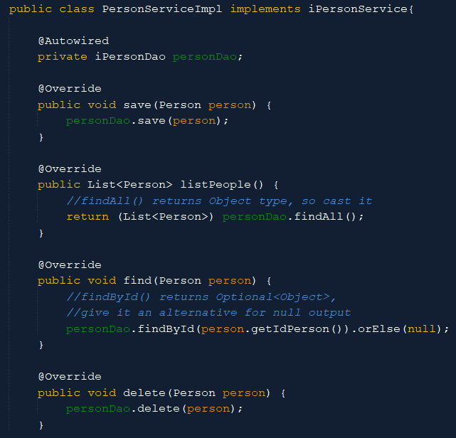

But we are still missing something. All of these methods will be transactional, meaning they will make queries to one or more tables. In case of error, a rollback will have to be applied, and in case of success, a commit will be required to finish the job.

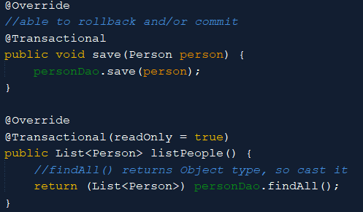

Every method will be annotated with @Transactional annotation. Be careful to import it from springframework. Read only methods will be specified as such, while methods that actually represent changes in the DB, will not be annotated with parameters, meaning a transaction will remain open, being able to rollback and/or commit changes.

Back at our controller, remember we had previously injected a DAO (Data Layer) Class directly into our controller, which is insecure. We will now inject a Service Layer Interface.

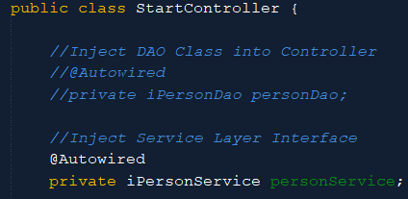

The reason why we inject an interface instead of a Class, is because an interface can be implemented by several classes, each of them will be tagged as a @Service and implement the same interface. This way, we can call upon any of those implementations via this interface and the interface will search for the right object type implementation amongst the tagged classes.

We can now use the interface methods from our controller.

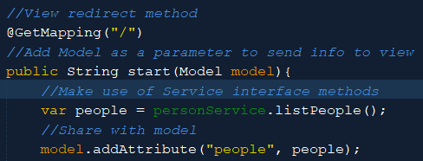

Our application is ready to run:

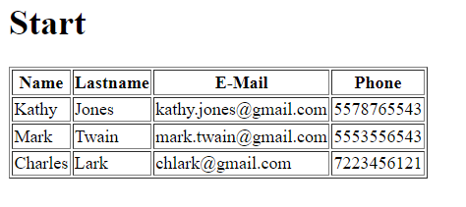

* **Spring Boot and MySQL – CRUD Creation:**

First of all, let’s make a quick review of CRUD (Create, Read, Update, Delete) preferred HTTP request methods for a specific resource:

**GET** 🡪 Idempotent (identical request can only be made once) 🡪 Get resources from Server. Ideal to **Read** resources.

**PUT** 🡪Idempotent (identical request can only be made once) 🡪 Make an update in Server. Ideal to make an **Update**.

**DELETE** 🡪Idempotent (identical request can only be made once) 🡪  Deletes resources from Server. Ideal to **Delete** resources.

**POST**🡪 Inserts into Server every time it’s processed. Ideal to **Create** even if identical items are being created.

* + **Create:**

First of all, we will add a hyperlink to a new page in our view that will serve to create an insertion in our database.

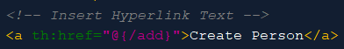 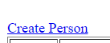

Use <a th:href=”@{*path from mapping*}”>Hyperlinked text</a> as the standard to insert links.

Now, at our controller, we need a new method for this new operation:

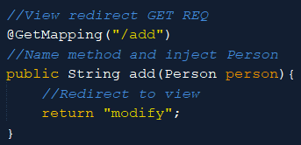

Use @GetMapping() annotation since it’s going to use a GET type request. Inject a Person instance by providing it as an argument. Spring will look for a Person type object in the Spring Factory. If it doesn’t exist, Spring will create it and inject it. This object will also be automatically available in the Request scope.

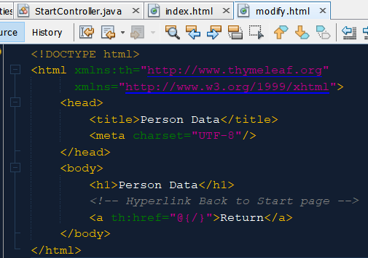

On the view side, we still need to create a new webpage called “modify”. Include the second namespace (w3) in order to remove DOCTYPE errors and apply strict html, meaning you need to close every single < with />.

First thing to do is to create another hyperlink back to the main Start page. Use <a th:href=”@{*mapper text*}”>*Text to be Displayed*</a> syntax to insert a hyperlink on the view side.

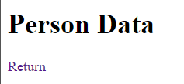

In order for Tomcat server to automatically reflect changes, and avoid restarting it every time, we need to select the following option:

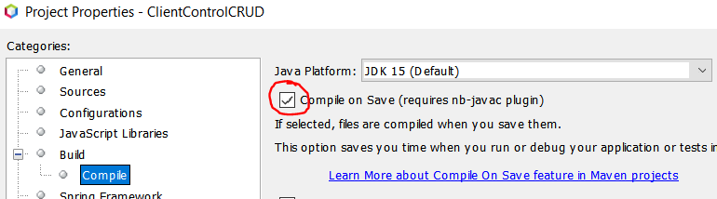

Now we need a form so that the user can fill in the person information. To create a form, use the <form label. The action property, will specify the controller URI that will process the information provided via the form. The method property makes reference to the http method used. Finally, the object property needs to specify the type of object that will be associated to the form and shared through the model.

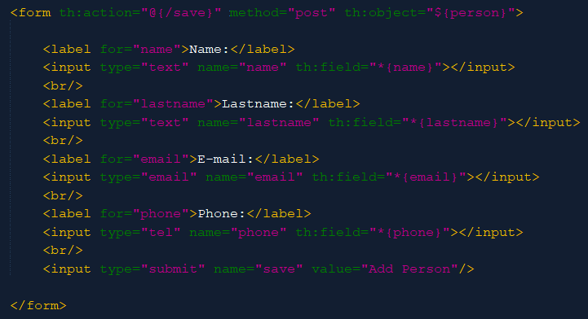

Notice when passing an object’s attribute through the th:field property, we will use the *{*class attribute*} syntax to make reference to the particular defined class attribute.

Finally, we add the Submit button in order to go to the mapping provided in the action property and perform the action defined in the URI.

In that sense, we still need close the whole flow for adding a new Person to our DB. So we will provide our Controller with the mapping for this action.

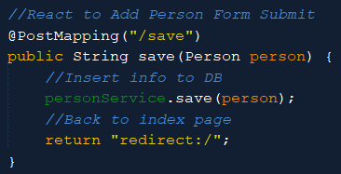

Remember that each time an object is passed as an argument to a function, the Spring factory will look for it and create it if it doesn’t exist and retrieve it if it finds that it already exists. In this case it will retrieve it along with the attribute values provided by the user into the form.

Using our personService we will make a straight input into our database.

Then, we want to return to our main page, so we use return “redirect:/”.

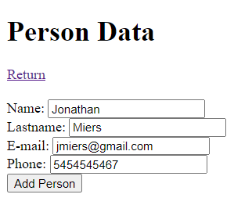

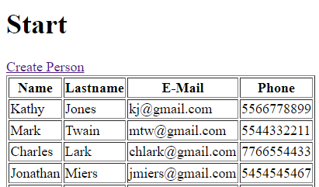

* + **Update:**

In our main page, we have created a table. We are going to add the Update and Delete headers.

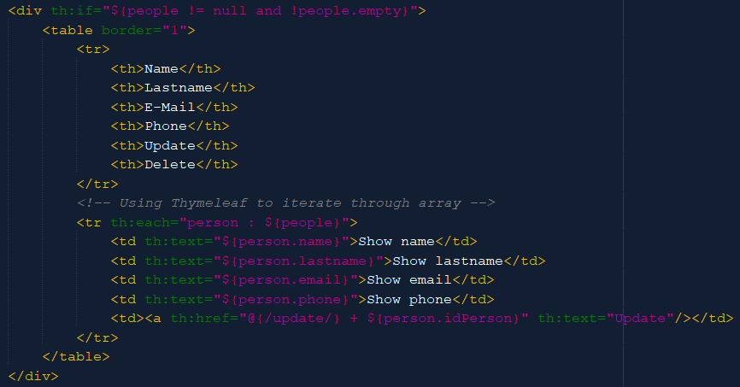

As well as table content with a hyperlink formed by the controller mapping concatenated with the person ID. This ${*person.idPerson*} variable is known as a Path Variable.

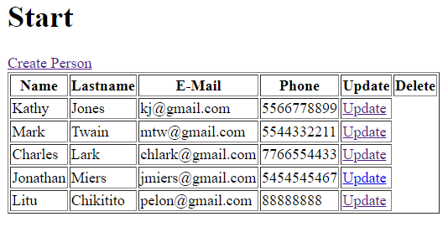

Now let’s go map this for our controller:

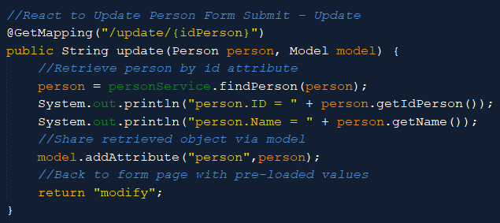

Use get mapping since this is to retrieve an existing resource from the server. Map it to “/update/{idPerson}”, this path variable needs to be called exactly what the attribute is called. The moment Spring factory looks for the injected Person object, it will retrieve the one with this ID, just as retrieved from the view:



Use personService to go retrieve the rest of that person’s data and assign it to the same person object. Don’t forget to share it via model. We will use the same form view so that the user can modify whatever information needed.

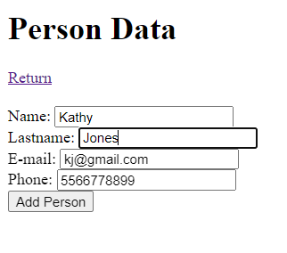

Information will be pre-loaded as the whole person object was shared in the Spring container and the view retrieves these fields by attribute association.

If we were to Submit this form, a new row would be created in our DB instead of modifying this one.



The last thing to do in order to be able to save these changes, is to provide the Person ID on the view side. The best way to achieve this is by creating a hidden input value and associating it directly to the idPerson attribute.

Now we are able to update existing resources:

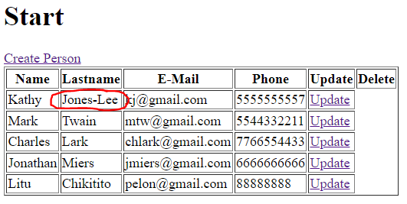

* + **Delete:**

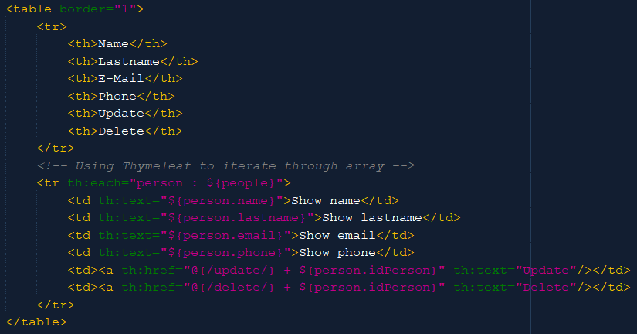

Introduce new table data with the new delete hyperlink and Delete text.

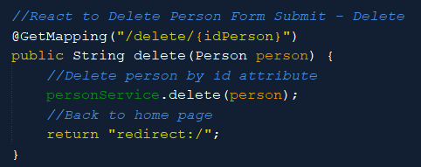

Map and define method for this action.

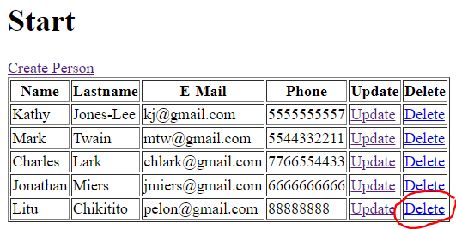

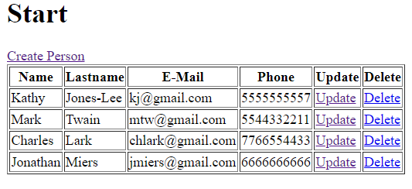

We will see the actual row disappear and since we are redirected to the same page, no other change is appreciated.

There’s yet another way to accomplish this. Instead of building an URI with a path variable, we could use a query parameter:



Now the URI will be builded as such:

*localhost:8080/delete?idPerson=1*

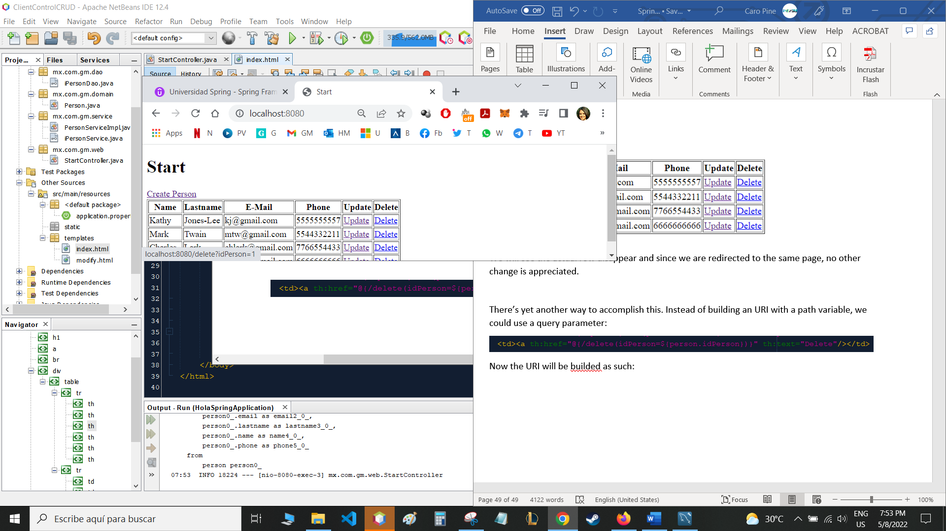

Last change will be on the controller side:

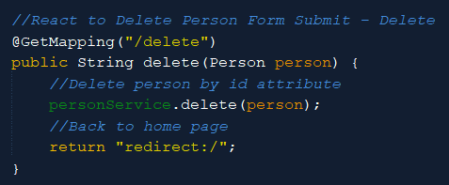

Since we are no longer using a path variable, remove it from the Mapping. We will receive the Person ID through the view, by defining the query parameter.

* **Spring - Validations:**

When working with forms, it is necessary to validate the input fields, meaning restrictions have to be made so that we receive only the kind of input allowed.

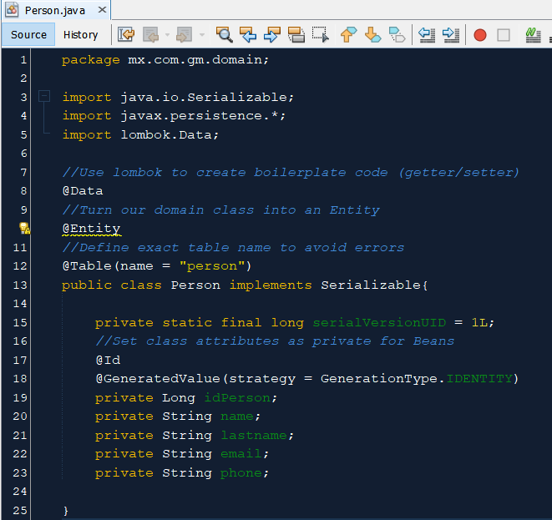

First off, we need to make some changes in our domain class in order to define business layer restrictions.

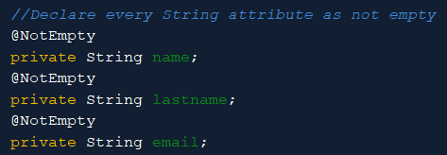

Every String type attribute can be annotated with the org.hibernate.validator.constraints.NotEmpty; @NotEmpty tag, this is to avoid user from submitting the form without filling one of these fields, checks that it’s not null nor empty.

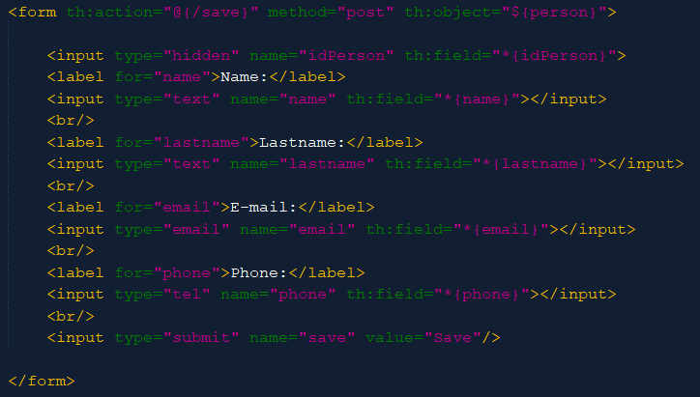

Now, our view side is not adapted to display the user with error messages. We need to tell the user what he’s missing in a clear way:

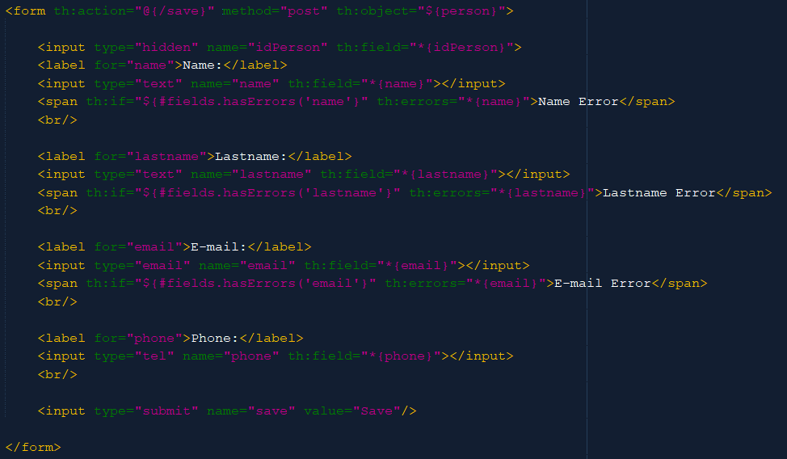

The <span> tag allows us to show text in case an if validation turns out true. In this case, we are using the #fields joker to call a function depending on the field input. Validate if it has errors and react with th:errors label by showing the errors in the given attribute.

Last but not least, comes the task of recovering said errors. From our Controller class, we are going to retrieve them. The action that will detonate such errors will be the pressing of the Save button, so the relevant mapped function will be the one that “saves”.

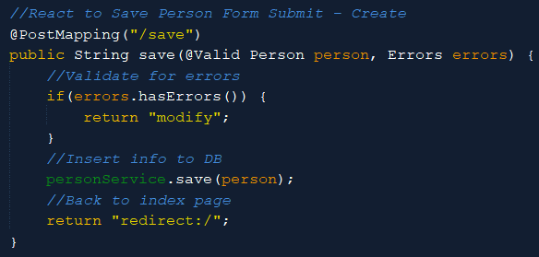

The first thing to do is to annotate Person with the @Valid annotation from javax.validation.Valid library. The second thing to do, is to inject an Errors class type object from the org.springframework.validation.Errors library so that we can use its methods. It’s important that these are the first two arguments received in the function, after them, we can have any other argument.

Next, we will validate for errors and if so, we’ll be returned to the same view, never allowing for a redirect to happen. The errors deployed in the view, will be defined in modify.html view.

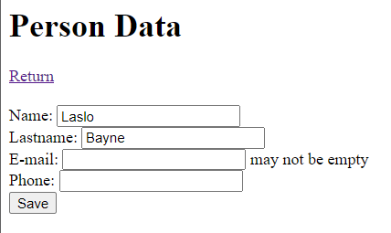

A different format from the type expected will not be allowed either:

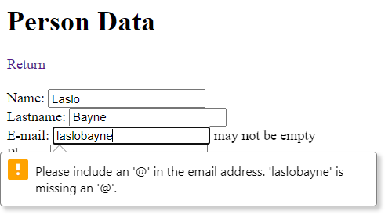

There is though, a standard e-mail validation in the javax library, so we are going to declare it as standard text in the front end (no HTML validation) and validate it instead, from the backend.

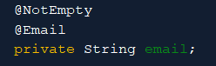

The E-Mail attribute should be not empty nor a simple text. Import the @Email annotation from org.hibernate.validator.constraints.Email;.

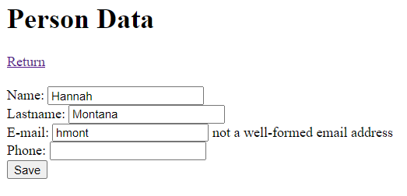

Now until a well formed e-mail address is inserted, the user will not be able to submit.

* **Spring – Thymeleaf Templates:**

We will create a new folder for our thymeleaf templates:

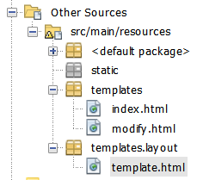

Our new template will have the same name spaces we’ve been working with so far. Add a simple title and header. This header will be a declared as a fragment so that we can reuse it for other pages. All of the code inside the header tags will be recyclable:

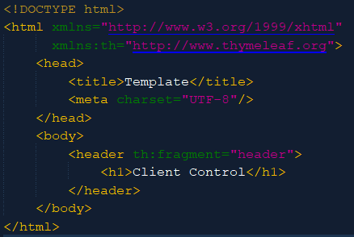

Now in our index.html view, we will call this fragment to display it:

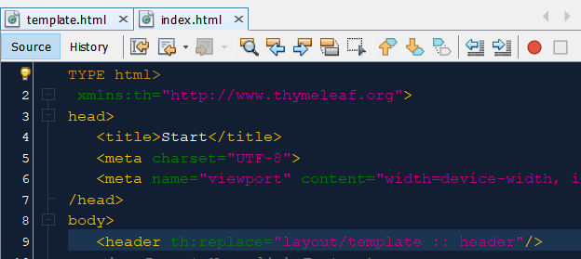

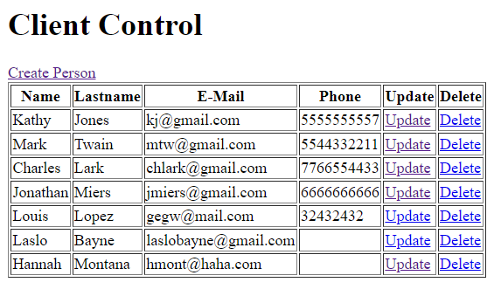

Client Control has now substituted the previous Start header.

Same goes for a footer fragment:





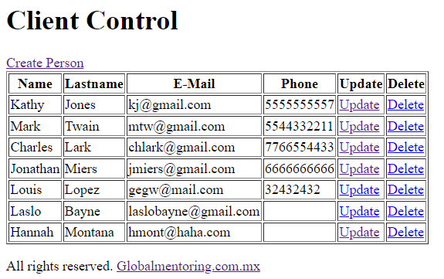

By using fragments, many other elements may be shared through view pages, such as a dashboard, menus, side bars, etc.

* **Spring – Messages:**

Instead of mapping html messages inside the view page, now we are going to retrieve them from a properties file. By doing this, we will be able to handle several languages, one properties file per language.

Create a new properties file:

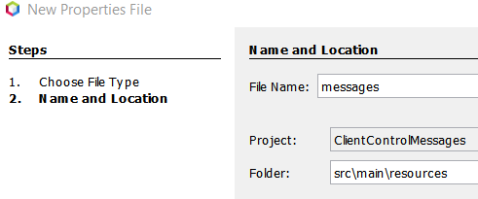

This file must be named messages in order to follow the default configuration mode, and be inside of the resources folder.

The primary goal of this file, is to store all of the plain text that we display in our html pages and assign it to a labels. For instance:

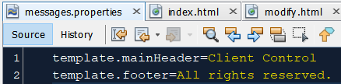

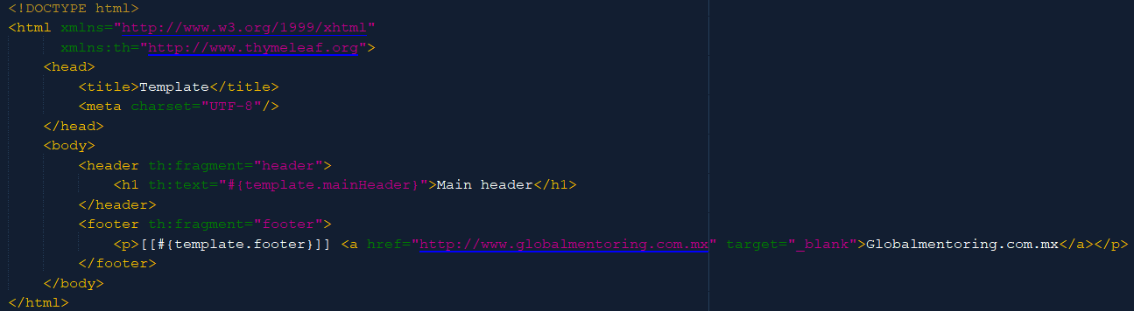

Use the th:text=”#{*properties.label*}” syntax to invoke the properties label from inside thymeleaf text property. If you wanted to call them from a plain text field, use the [[#{*properties.label*}]] syntax, in this case, done not to lose the hyperlink.

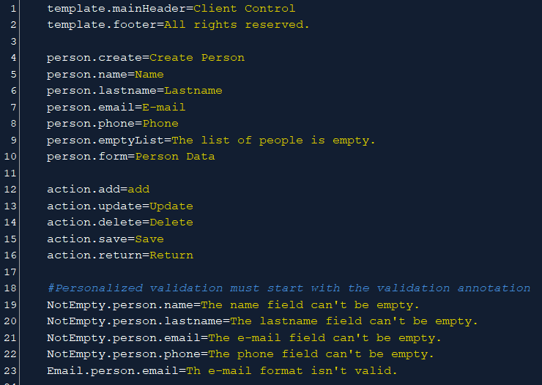

We can personalize every single text used in our view pages, plain text, object attributes, actions, error messages, etc.

For the field validation case, variable names must start with the annotation name. While using this syntax, the message we have defined for every specific error will automatically be retrieved from this file and deployed in the front view.

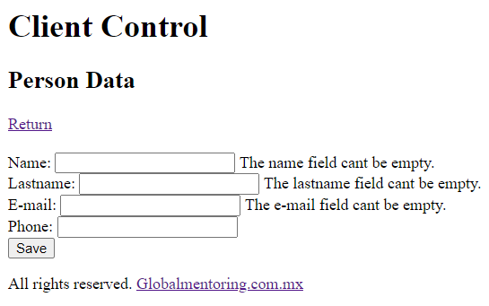

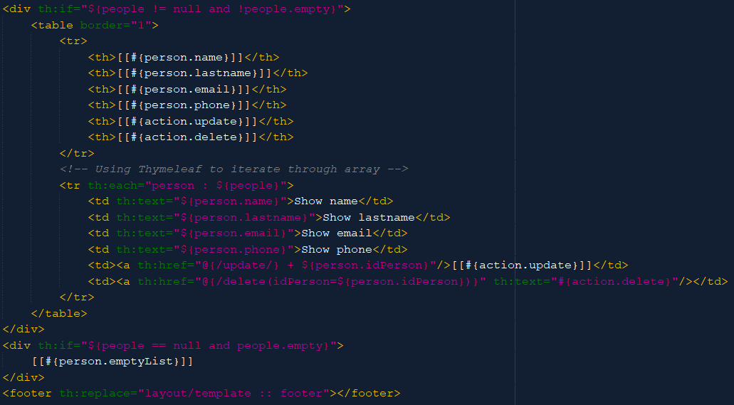

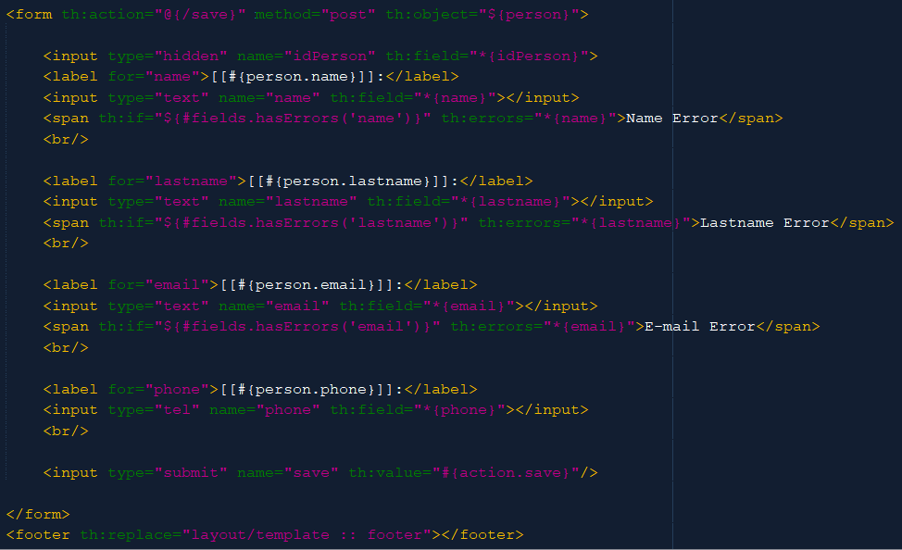

This was useful to replace all of the plain text in our Thymeleaf pages. Now, this is especially resourceful when making websites international.

* **Spring – Internationalization (i18n):**

First of all, we will create a new class 🡪 WebConfig, which will be inside the web package. This class is part of the MVC pattern and will implement a corresponding interface. This class needs to be annotation with the @Configuration annotation from Spring Framework Context.

This inferface has several methods that we will implement, such as addInterceptors, useful for Internationalization. Use the @Bean annotation to create a bean class instance that will be automatically added to the Spring container context.

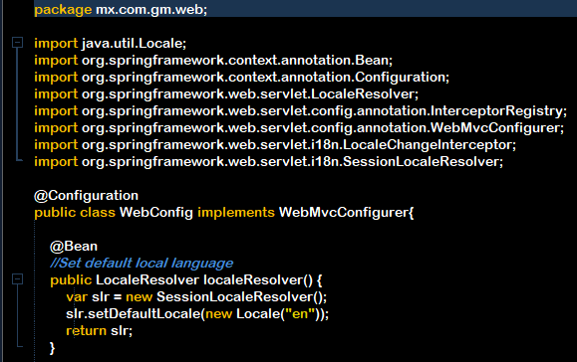

This class will have several imports related to the servlet behavior.

First thing to do is to create an automatic instance of a SessionLocaleResolver and add it to the Spring context. This will give us a default language to work with.

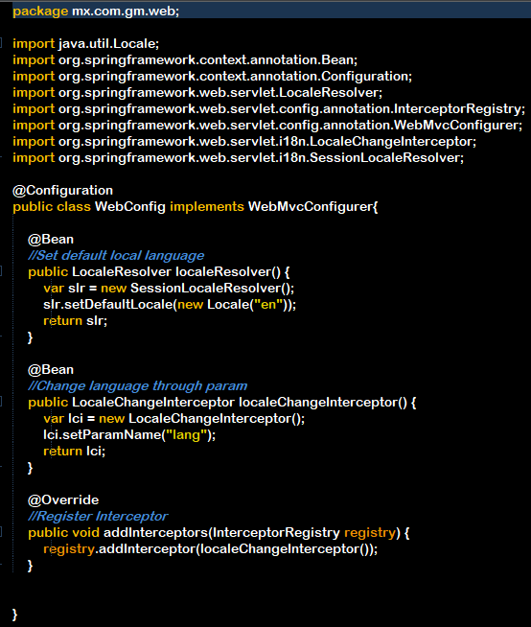

Add an addInterceptors method implementation so that lifecycle interceptors for controller invocations and handling before and after processing are managed. Our class is now ready to dynamically change languages. Language management will be controlled through a properties file.

Right click in the messages.properties file and select Open to visualize the file in a Key 🡪 Default language pair mode.

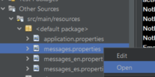

Now copy this file multiple times, one for every language you want to manage.

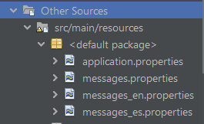

Rename them using the corresponding language suffix. Now messages.properties will contain all of the Key – message equivalencies for every language case.

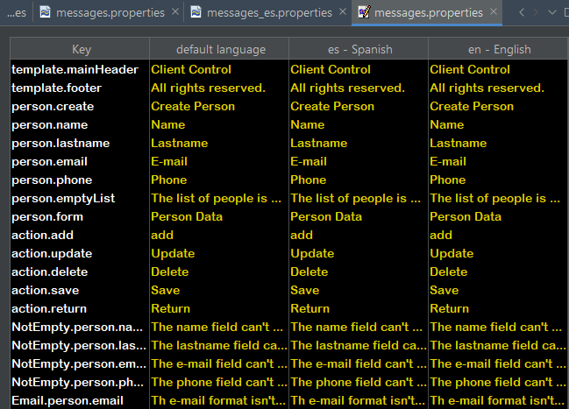

Without modifying the Key column, we will translate the es – Spanish column to the desired equivalent value:

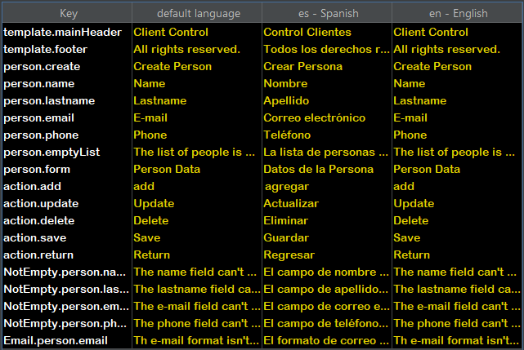

Last, we will implement this somehow from the view so that the user can select another language:

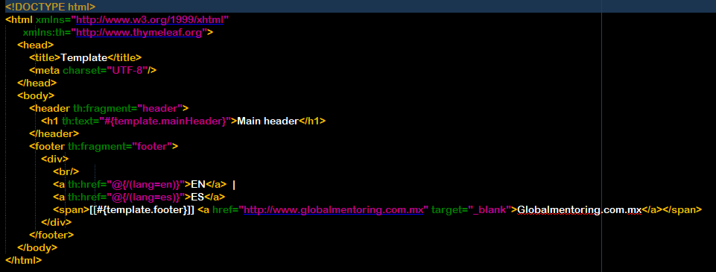

This is our index page now:

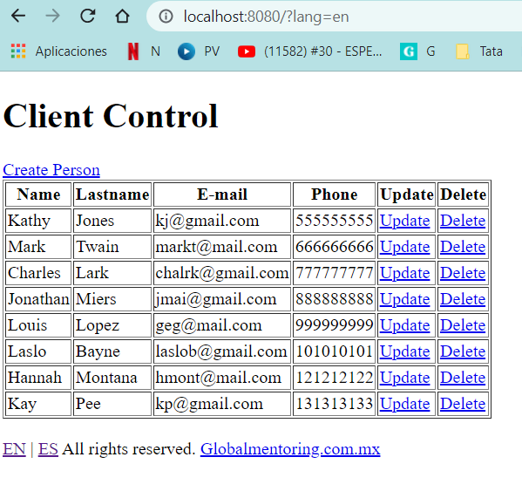

Spanish:

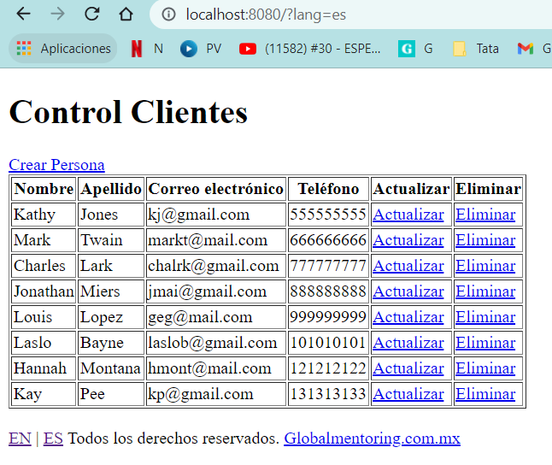

* **Spring – Security:**

Before doing anything else, we need to add the Spring Security Dependency to our project:

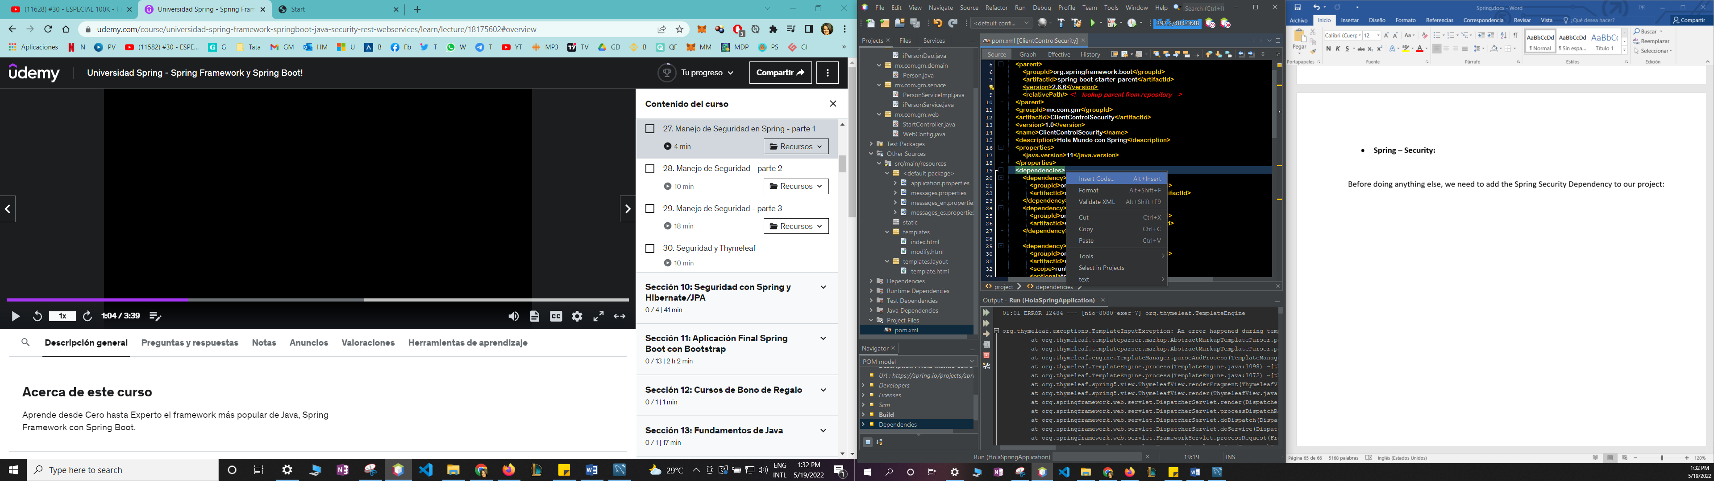 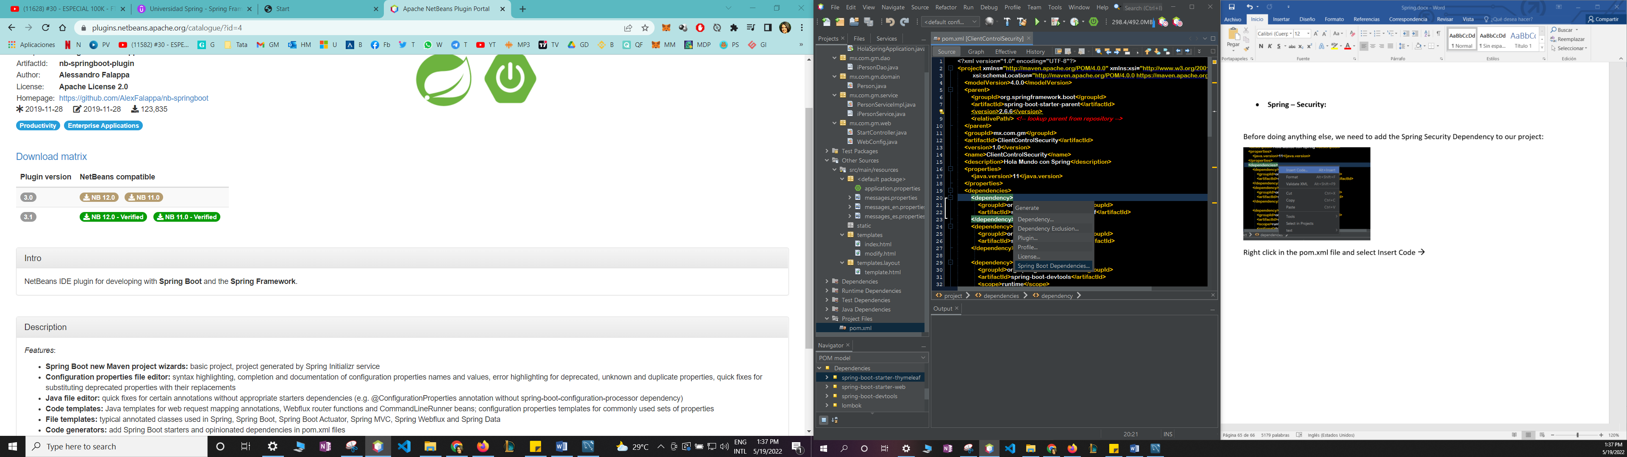

Right click in the pom.xml file and select Insert Code 🡪 Spring Boot Dependencies…

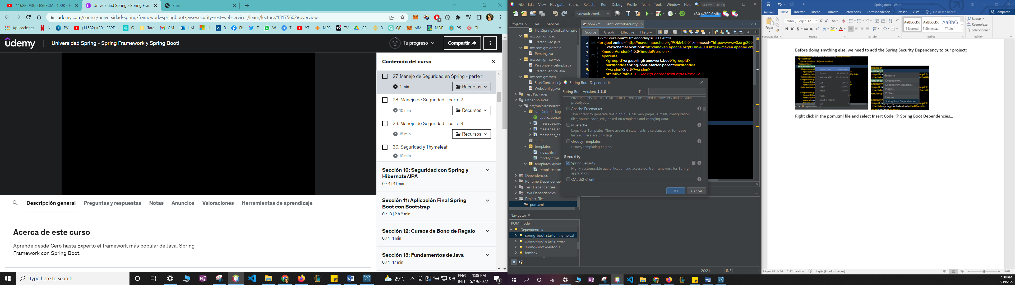

Tick Spring Security and then OK.

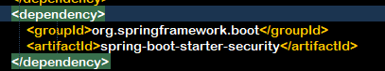

Just by adding this dependency, a password was automatically generated when the project ran:



Using generated security password: 5aec68d0-e8c6-4cb4-842a-fee2cea2e952.

Also by default, Spring Security created a generic login page and is asking us for credentials. The default username is “user” and the password will be visible in the Application deployment log.

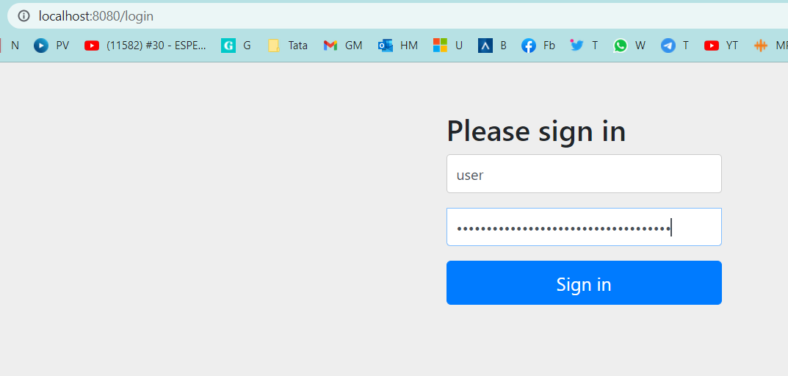

Though we have a first barrier, we still need to configure other aspects of Spring Security.

Create a new class in the web package:

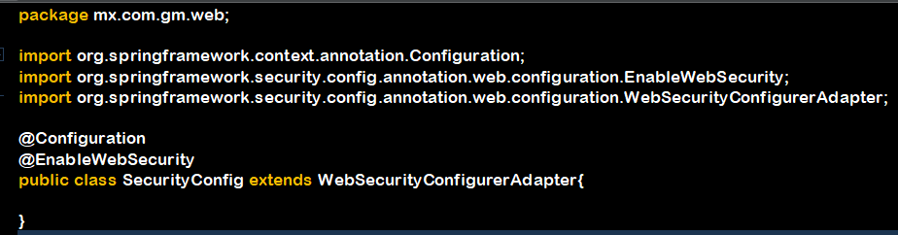

This class will manage the aspects of Spring Security and must have a related name. Annotate if with @Configuration so that configurations herein defined are included in Spring’s Application Context. Also use @EnableWebSecurity as a marker so that Spring can add this class to the framework context. Last, extend from WebSecurityConfigurerAdapter. These 3 steps will form up the applicationContext.xml file indirectly.

The first method, known as *AUTHENTICATION*, will be used to restrict users allowed into our App. User must present its credentials in this step.

We will create two dummy users authorized to access our application and give an example of the syntax:

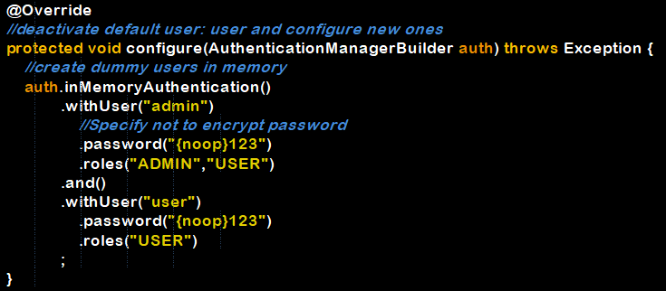

By using the Authentication Manager Builder instance, we are able to call the methods in it. Use withUser() method to set a username, call the rest of the methods concatenated to define the user’s password and roles. Behind the scenes, Spring will automatically change the role label syntax, for instance: role_ADMIN.

Spring is now expecting one of the recently defined credentials to allow login. Any other combination will be denied access:

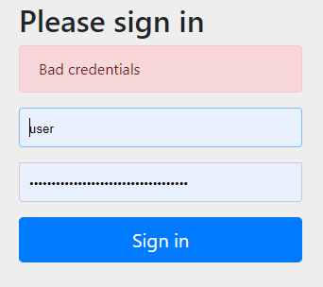

Let’s add a Logout function in our web page so that we can try out both users. Remember logout’s http method must be of type POST due to the kind of submit (link in a form) we are going to send.

To tell Spring Security that we want to logout, refer the action to @{/logout} and direct the link’s href to “#”. This doesn’t need to be specified in any Controller.

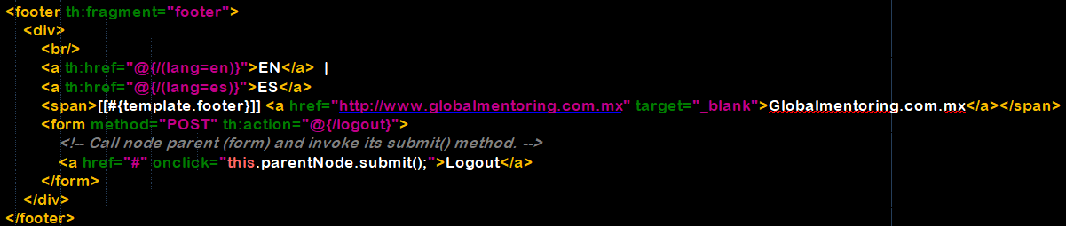

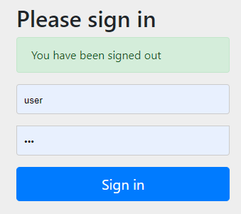

The second method, known as *AUTHORIZATION*, is a method override of the first one. It will allow us to determine which users will be allowed into our application per path and restrict http requests according to controller mapping by user role:

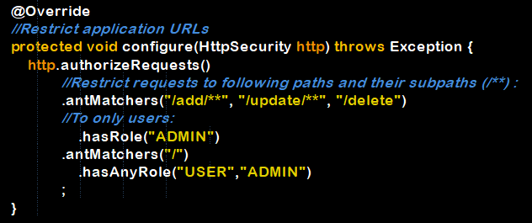

We will restrict authorized requests to be made only by a user with the role ADMIN for the /add, /update and /delete mappings and their submappings. All of the other roles are allowed to access the index page.

To achieve this, we must first create a default url mapping that doesn’t go through our Controller, but uses an implementation of addViewControllers method from WebMvcConfigurer interface (Our Webconfig class).

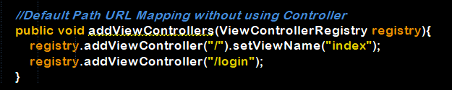

The first view we get is the index page, which won’t be dislayed until we login. So we need to add another view called login, for this action to be performed in correct order. This view will override the previous default login page provided by Spring.

Create a simple login form page:

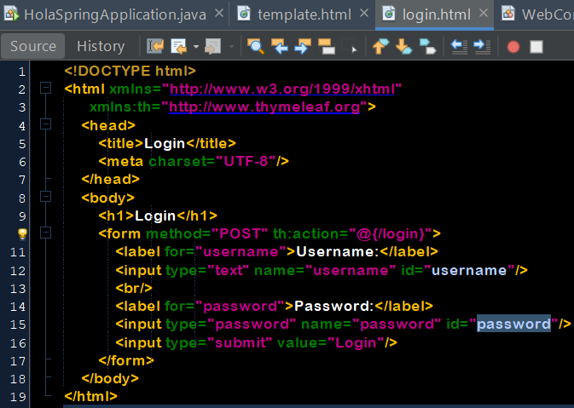

Remember login and logout actions must be performed through POST method and the action mapped on this side has to be @{/login} or @{/logout}.

Of course, Spring Security should also agree with this. Provide the new login page in the list of authorized http requests:

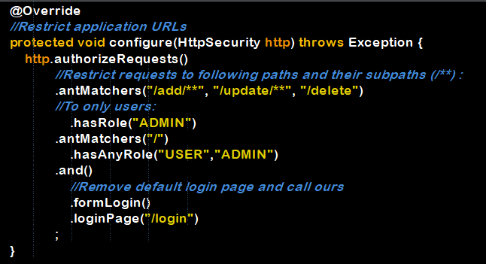

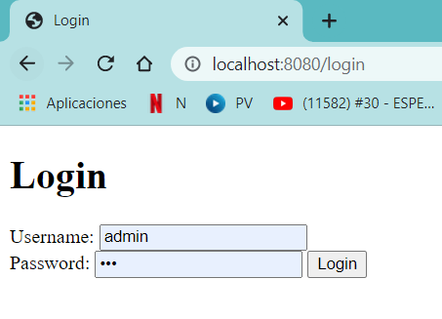

Login using credentials to test the rest of the configurations given.

For example, a regular user must not be able to create a new person and insert it into DB:

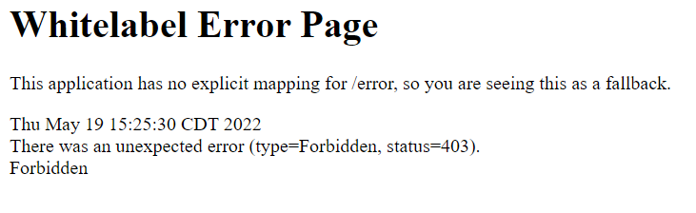

Let’s create a custom error page for this kind of situation. Create a package since many errors may arise and we’ll need to address them all:

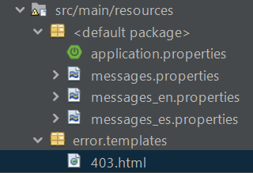

403.html:

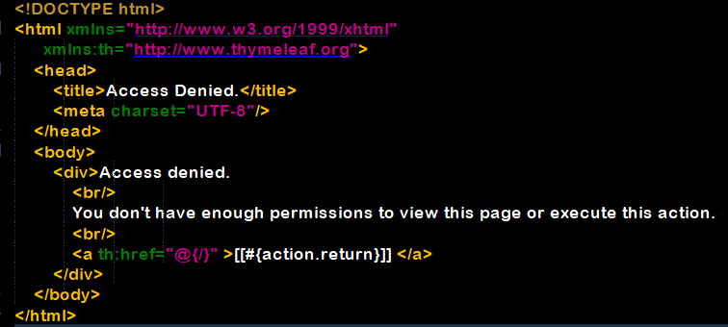

Remember this error page will be displayed without going through any controller. We need to add it to WebConfig’s addViewControllers method to map it and authorize it from SecurityConfig’s authorizerRequests method as well:

WebConfig.java:

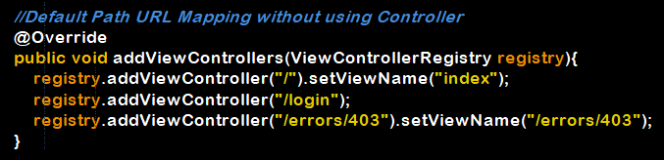

SecurityConfig.java:

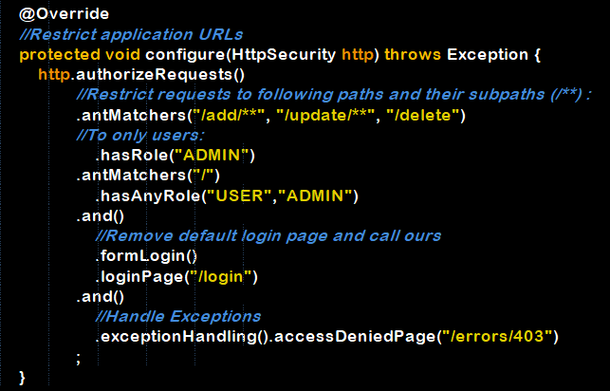

Now that we have achieved our login and restricted access by user to several view pages, it’s time to give back control to our actual Controller class.

First of all, we need to retrieve the user back from Spring Security.

Annotate the User with @AuthenticationPrincipal to retrieve user from Spring Security login.

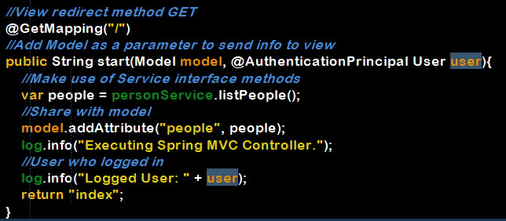

Be careful to import from proper package:



We can now see in our log, the logged user credentials:



* **Spring – Security with Thymeleaf:**

First thing to do is add another Thymeleaf library to our pom file, which contains security features for our web pages.

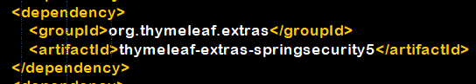

Now, all of our pages need to include the spring security name space as well:

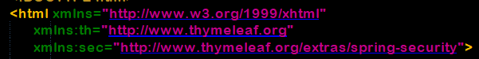

The security attributes are now accessible to the front end by calling the sec:authentication tag as such:



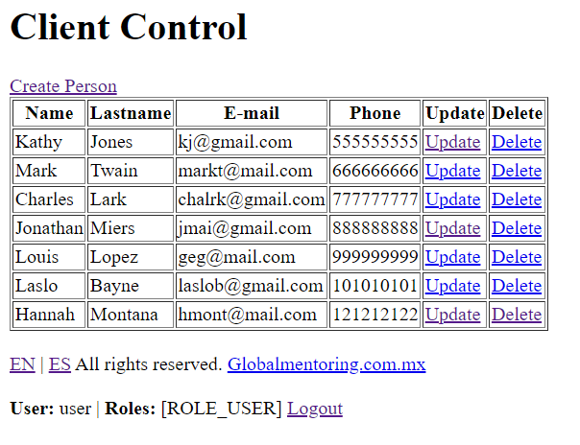

If a user doesn’t have permission to Create a new person, Update or Delete an existing person in the table, the right thing to do would also be to deprive them from Reading the registry at all. So let’s choose to hide certain information in our web page depending on the user logged.



This link (create person) will only be shown to a user with the ADMIN role.

Same goes for the Update and Delete column content:

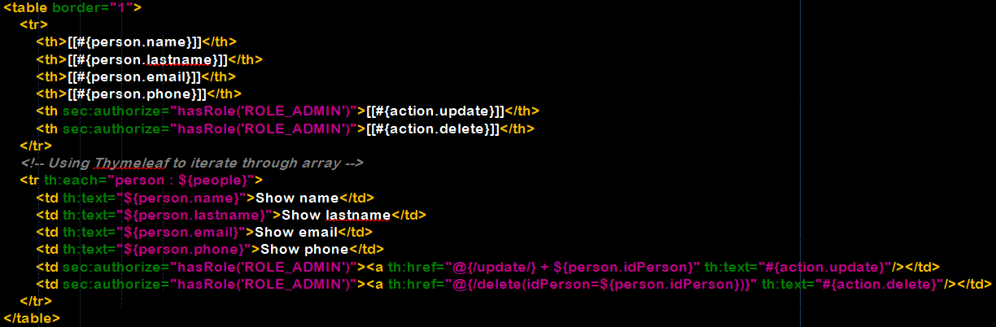

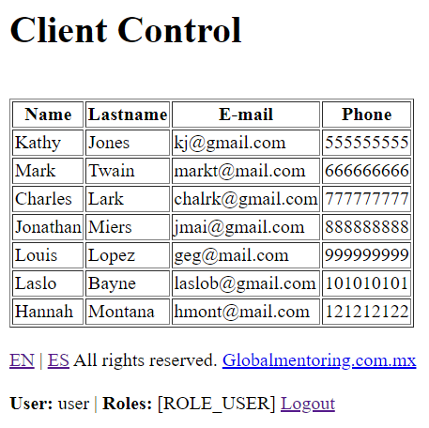

The unnecessary hyperlinks are now hidden for every simple user profile.

* **Security – Spring and Hibernate/JPA:**

First of all, let’s create a new table in our DB dedicated to store our users’ information. Use 128 chars for passwords since they are usually larger due to encryption.

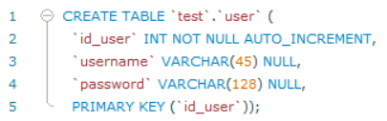

Now we need another table to store user roles. A user may have several roles, so we need to relate both tables through the user ID.

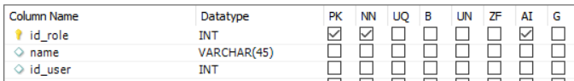

Now let’s relate them by using a foreign key:

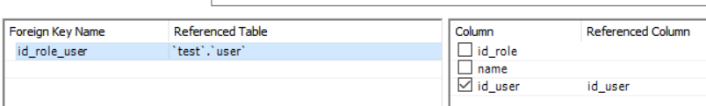

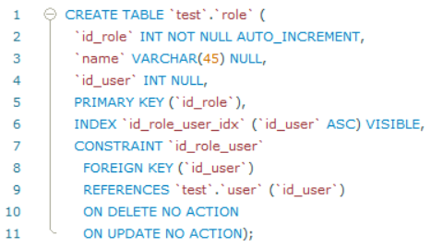

Populate user and role tables:

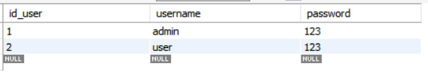

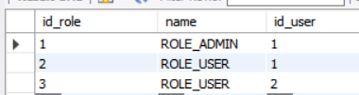

Back at our project, we will need a Utility class to help us encrypt our passwords, which must never be stored in clear text in our DB:

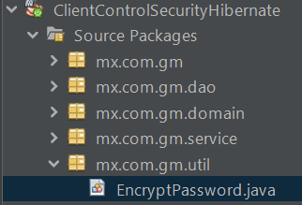

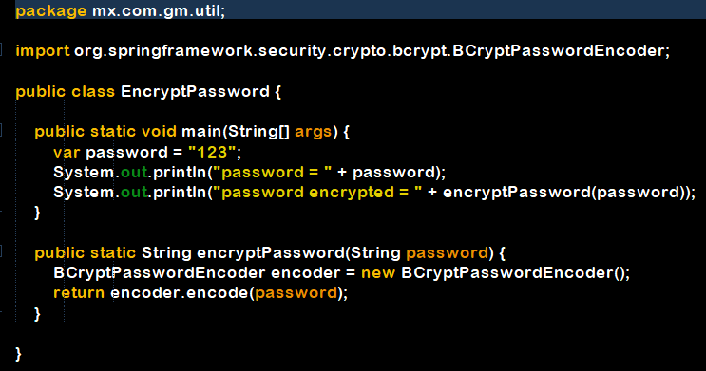

Our class is ready to encrypt, so right click and run it twice to generate the encrypted passwords for both users, make the corresponding updates in the DB:



Since we made 2 new tables, we need to create our new Entity classes for User and Role.

Create first the entities that have no dependency with any other class, in this case Role class. Remember the User class will depend on the Role class through the id_user column.

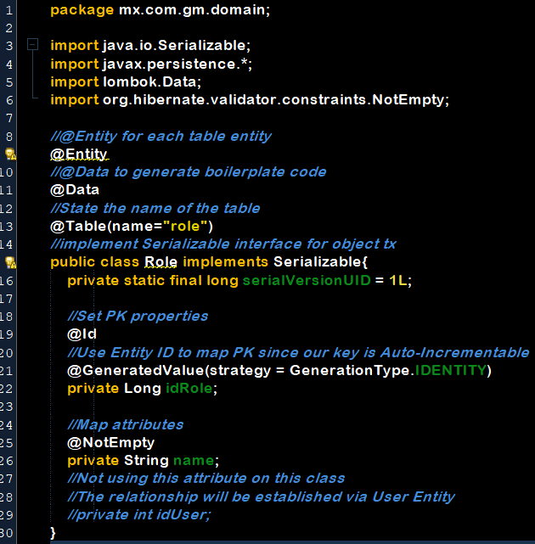

The User class will be the one that maps the relationship. In a OneToMany kind of relationship towards Role, One User may have Many Roles. We will relate both tables through the user id and be returned a list of roles after query.

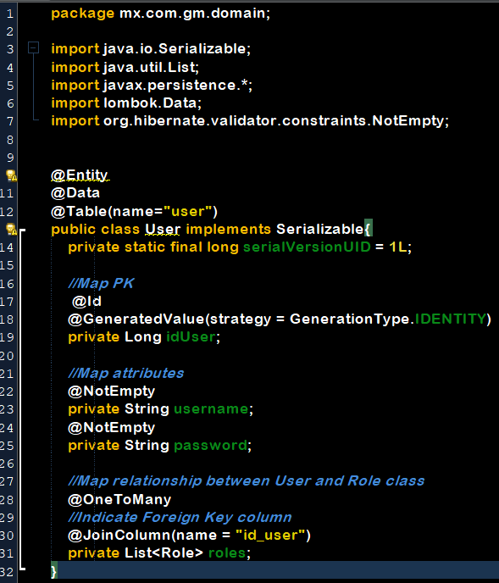

Create a DAO interface that extends JpaRepository. After this, Spring will create an automatic interface implementation (no need to define methods unless you wanna customize or override them). The only method we actually need to define is the findByUsername method, due to Spring Security specifications, pass the variable name parameter for username.

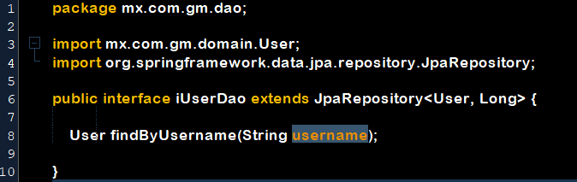

Next step requires a service class in order to implement queries. Mapping User business-persistance queries is so common, that Spring actually already offers an interface that will have a method to fetch a user object given its username. It’s called UserDetailsService, and the service must be named exactly this:

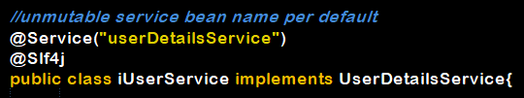

Now we will implement UserDetailsService, an interface predefined by Spring to handle user information that will return a UserDetails interface type object:

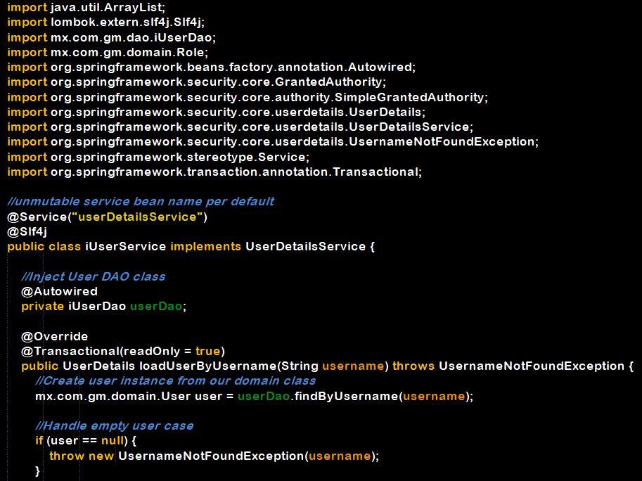

Inject the DAO object to handle transactions. Implement the only method loadUserByUsername by providing a username. Retrieve the user aided by DAO class. Is user is null, be prepared.

Next, retrieve the user roles aided by Granted Authority class wrapper and build a list. Build a Spring user giving the arguments to the constructor.

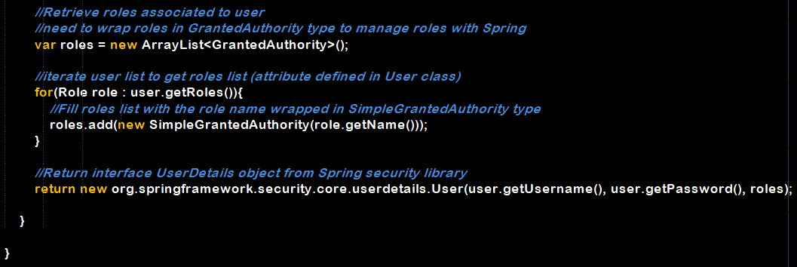

The last step will be to configure Spring SecurityConfig class. We’ve created a new service, so let’s use it:

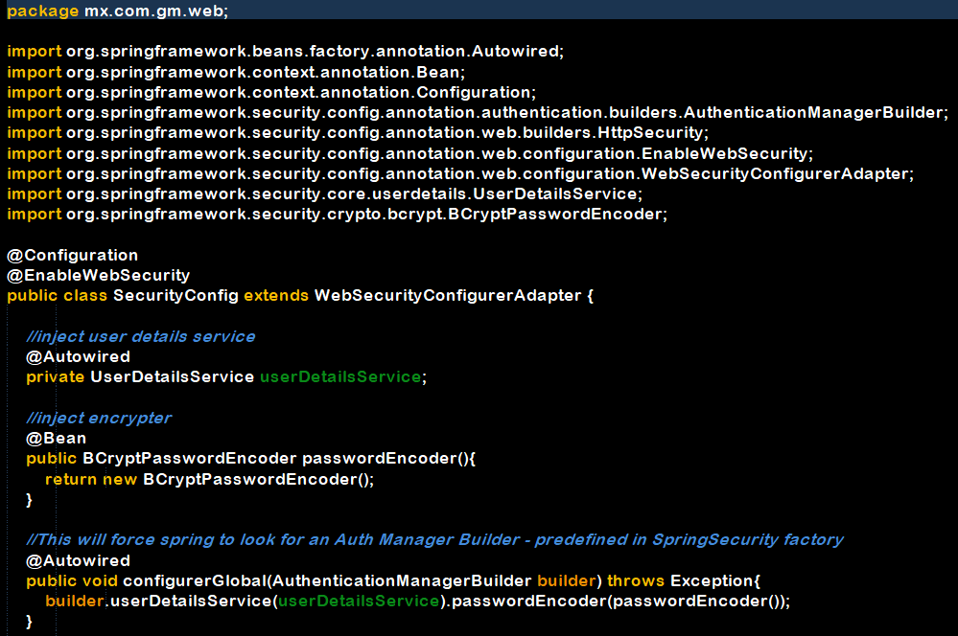

In our SecurityConfig class we will inject a user details service object, as well as an encrypter object.

Next, inject the configurerGlobal method, which receives an Authentication Manager Builder object as an argument. This object is automatically managed by Spring Security factory and hence, readily available.

This will facilitate our job in order to implement the userDetailsService we mapped to userDao class and the roles associated to it. Since our services was named userDetailsService, it will go fetch it with all the loaded details it got from its only method and build the authentication.

Simply use this method and remember to encode the password while building the builder object.

* **Add Bootstrap:**

Bootstrap is added for visual improvements on the front end. First of all we need to add the corresponding dependencies to our pom.xml file.

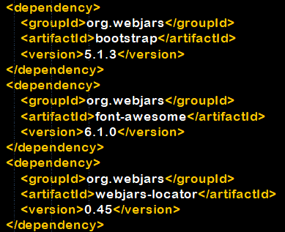

The webjars dependency contains several libraries such as bootstrap, font awesome, jquery, etc. Font-awesome will provide with some icons we’ll need.

Now let’s add bootstrap provided utilities to our html templates, start with the shared template and declare the header as a fragment.

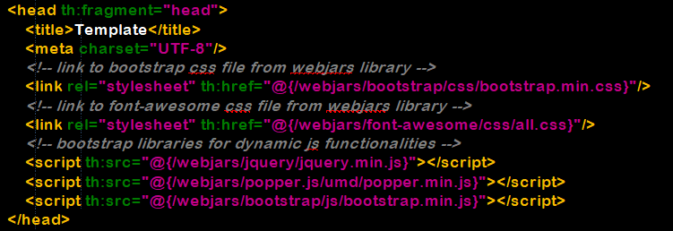

Then share it with the rest of the pages:

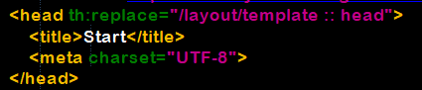

Verify changes by inspecting page HTML code:

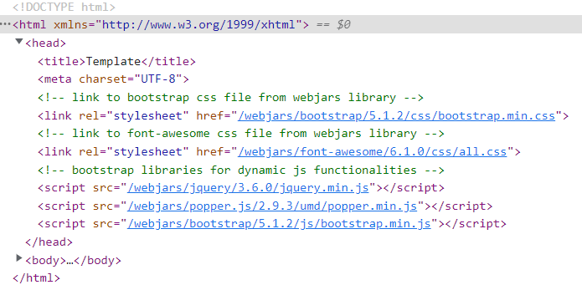

Also, make sure all sources were loaded:

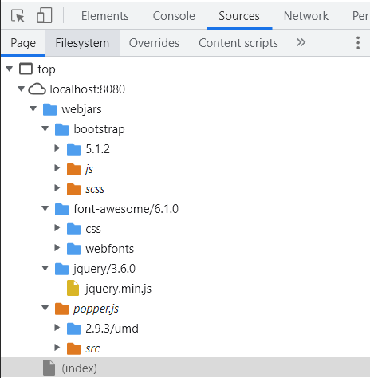

Make sure every href and src link deploys a valid file, otherwise upgrade versions and verify configuration file.

Last, test all page components’ functionality.

When using bootstrap, the first visible improvement is the font and style:

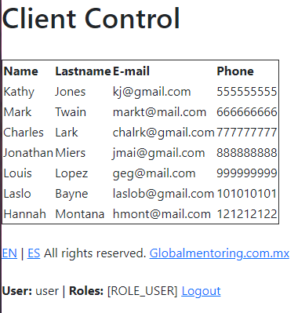

**BOOTSTRAP**

* Stylesheet imports go in html header, components are implemented according to bootstrap documentation in html body.
* Implements “mobile first” meaning it will attempt to adjust in mobile screens before adjusting for larger ones.
* Works with div container blocks.

Now, let’s start using some of the components offered by bootstrap and add a navigation bar:

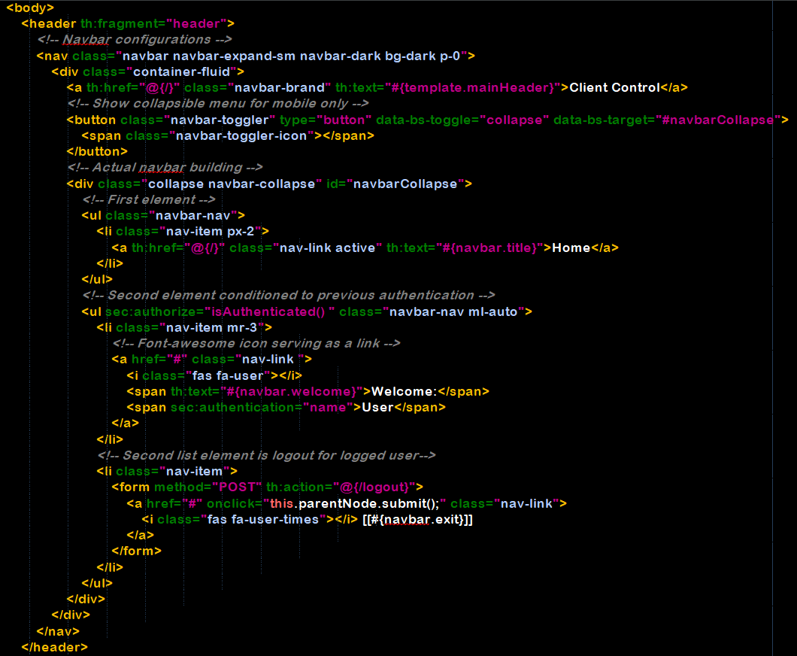

Remember bootstrap offer documentation for every component: <https://getbootstrap.com/docs/5.1/components/navbar/>

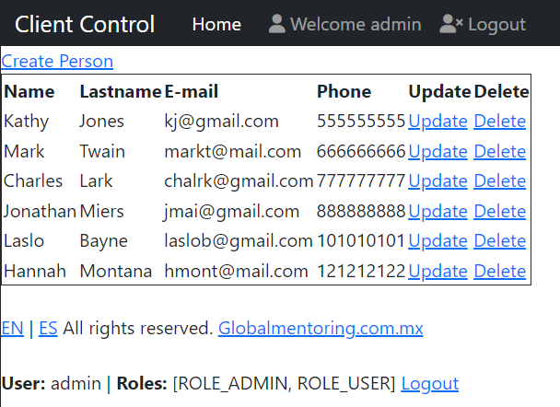

We can continue adding multiple Bootstrap components to our webpage until we are satisfied with the style of it:

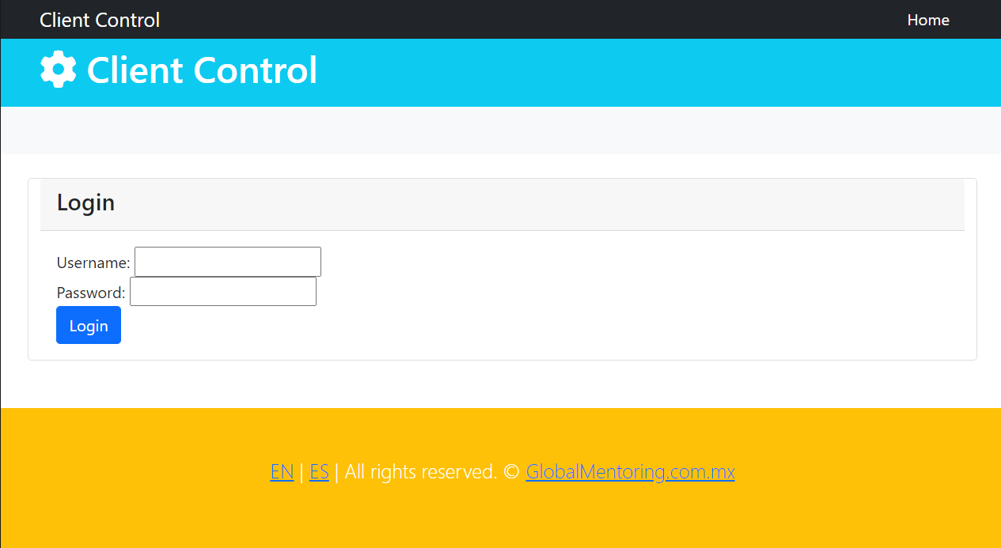

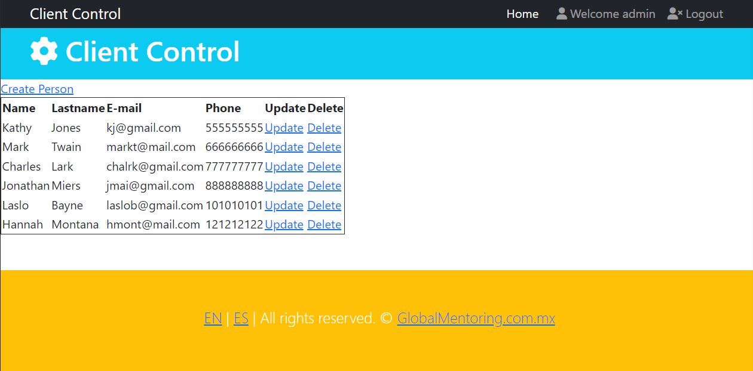

* **Sections:**

For a clearer page organization, we can organize our web pages into sections:

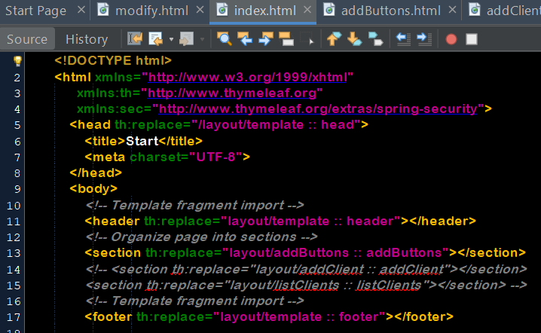

We will import these sections as fragments to give them re-usability.

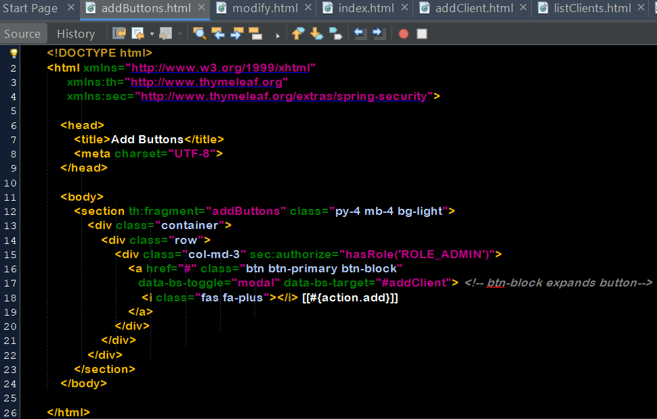

This way, we can manage every page section in a different document.

Add a new column to the Person table and also to the domain entity:

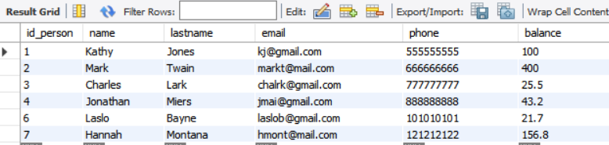

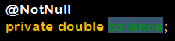

Annotate it with @NotNull since @NotEmpty is meant for Strings.

Now, we will change the index of our main page, to show a table with the client’s index, name and balance of every client:

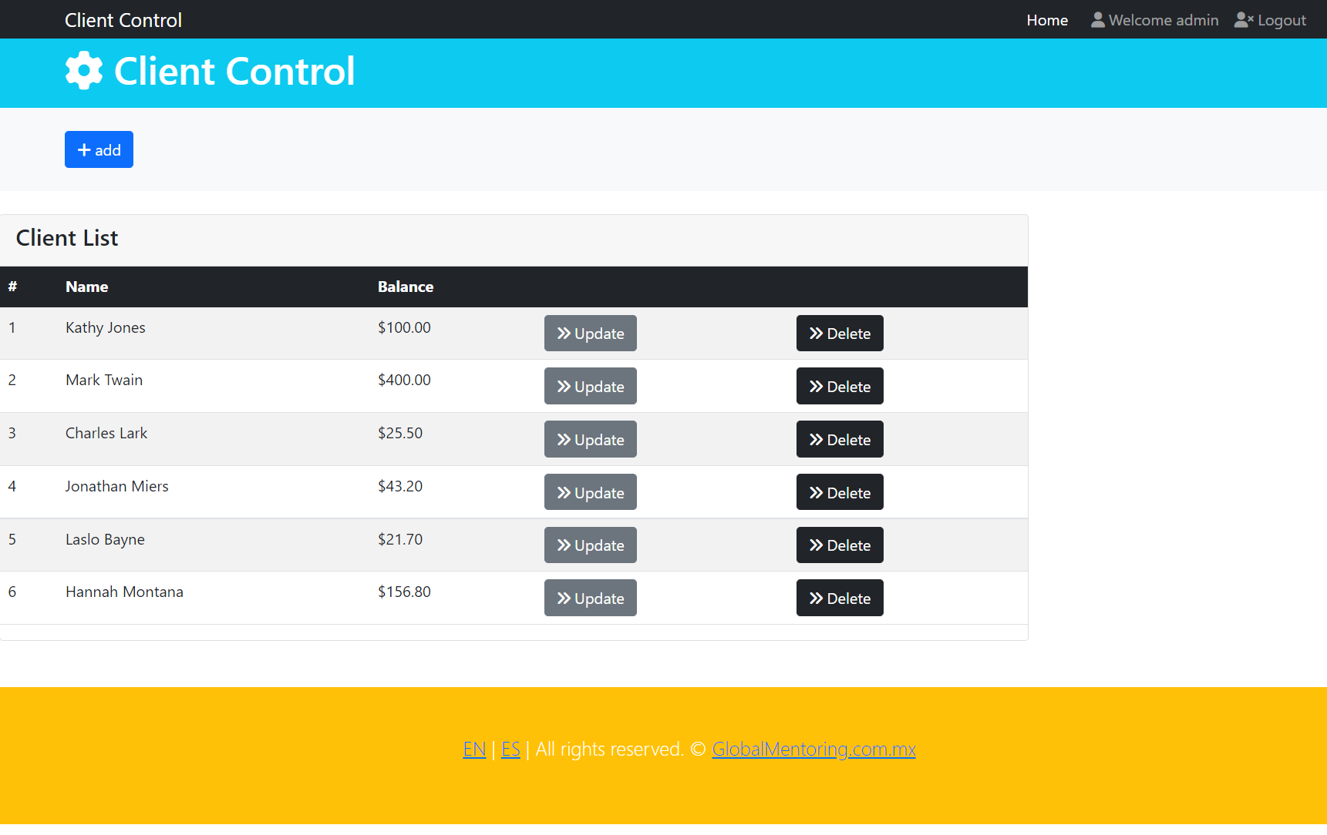

This was the listClients section, called from our index page:

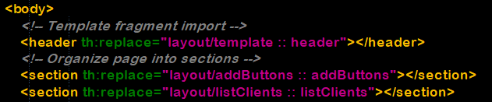

We achieve this through th:each, which iterates an array and provides an interator, in this case we called it counter:

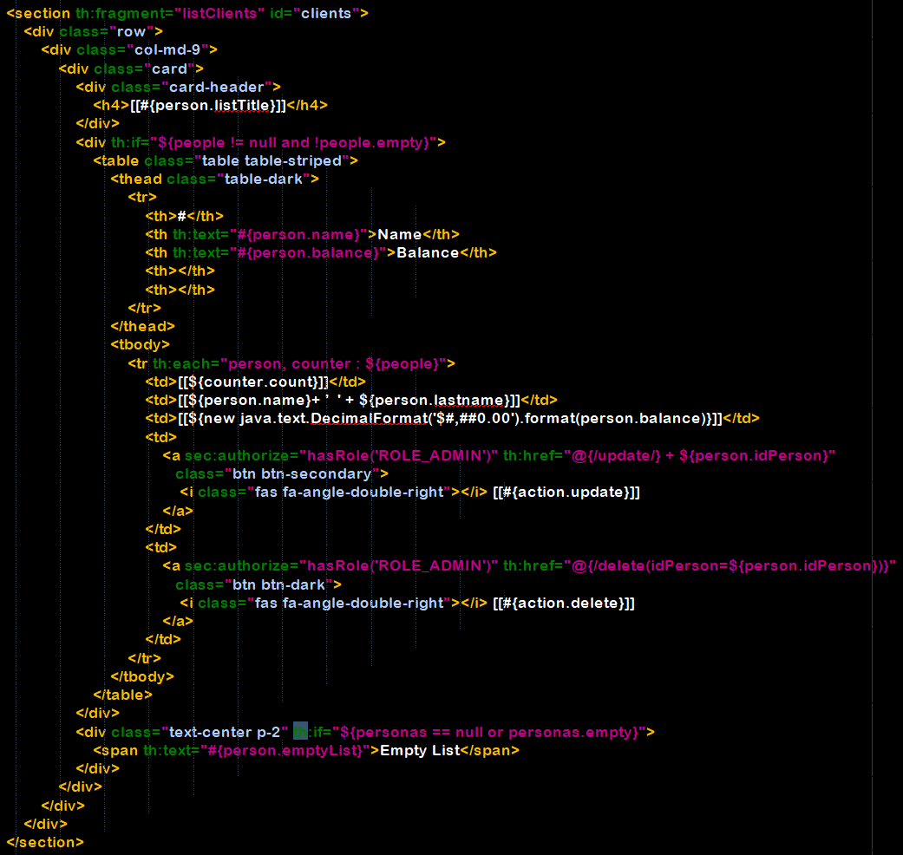

We will also add two little cards showing out total customers and total balance:

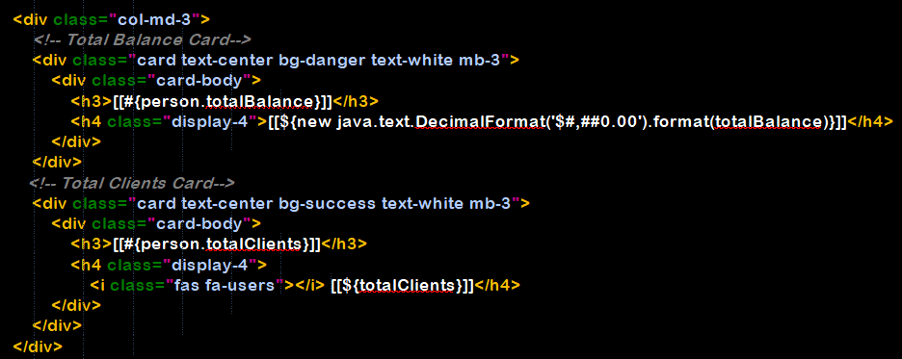

Two new text messages will be invoked from the properties file (using #[[]]):



And two new variables will be handled via Controller, shared from the index request:

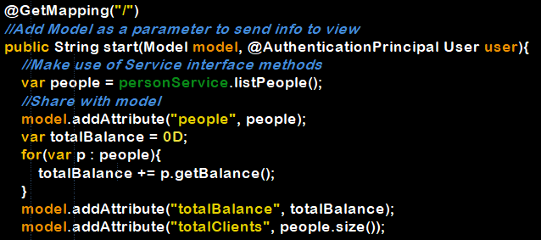

Our page now shows the required info:

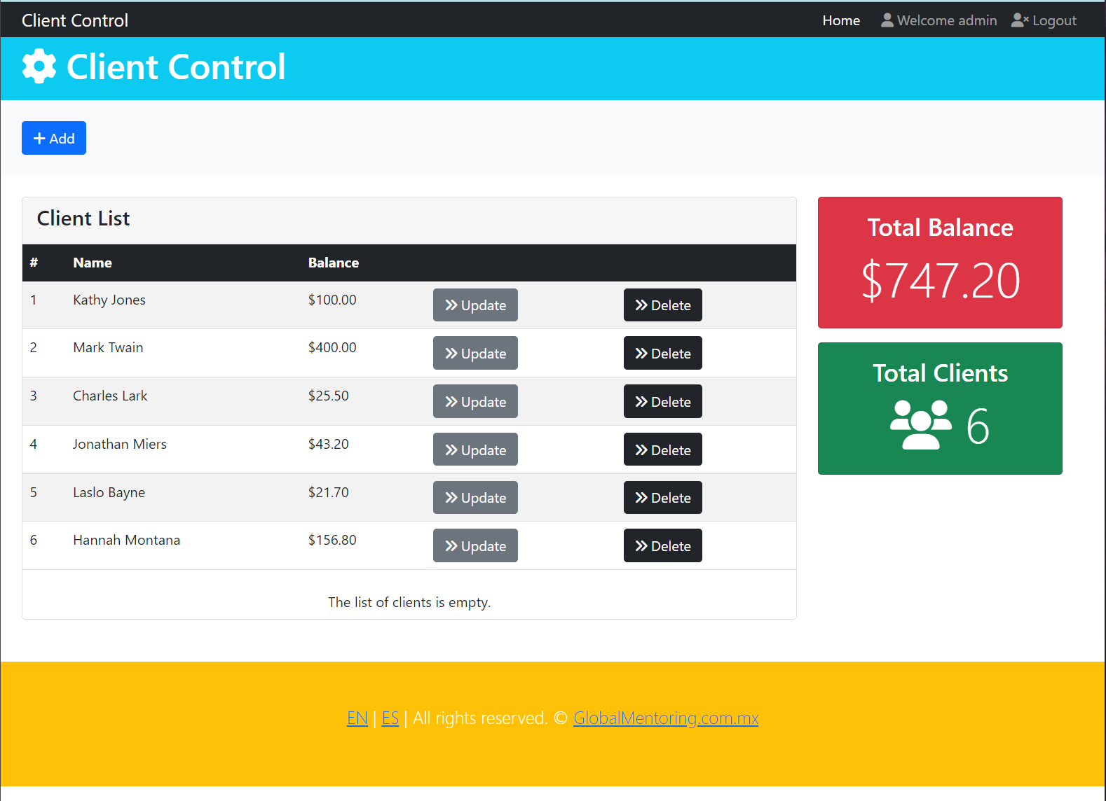

Let’s now move on to the last section:

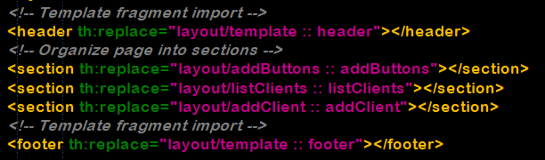

This section will basically be a modal popup containing a form with bootstrap and HTML5 validation:

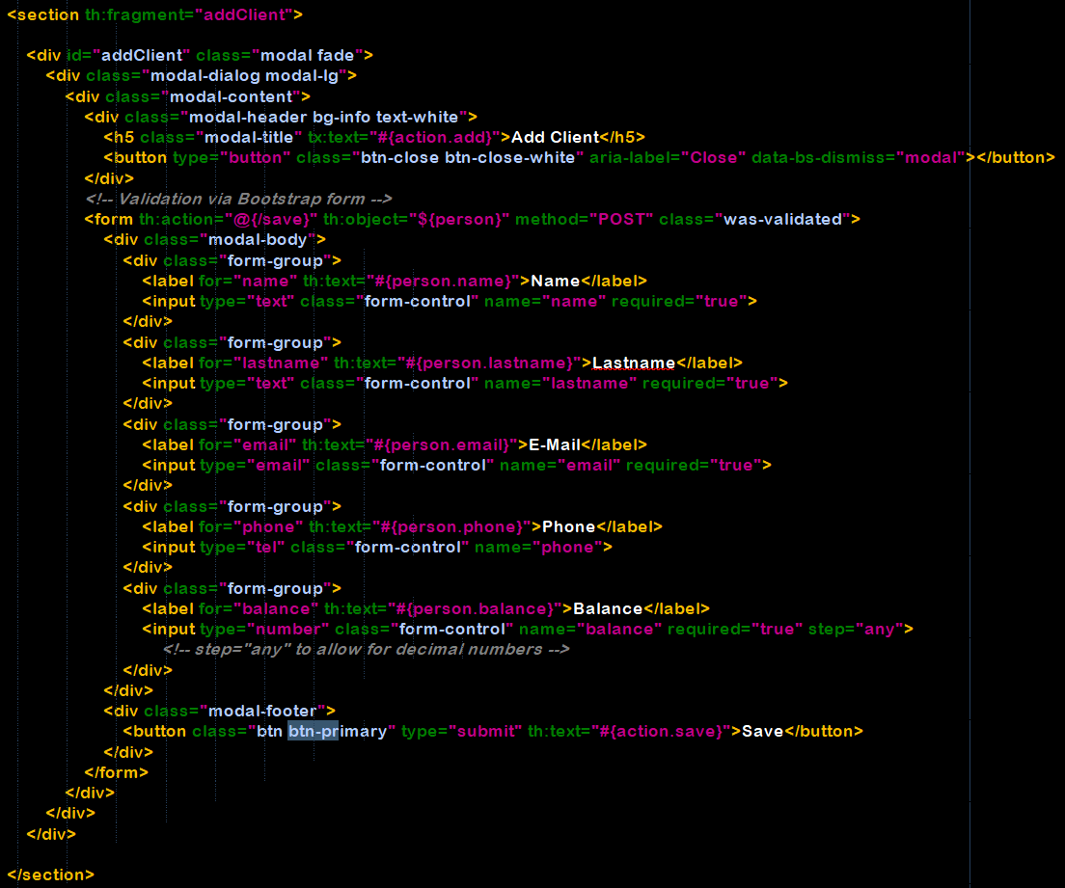

Thanks to the +Add button redirection, we are redirected to #addClient, which is the id of the section fragment:

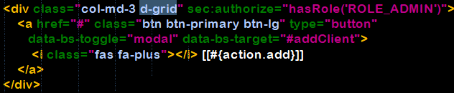

This is the final outcome in the view side:

